Bank of England

Inflation Report

November 1995

Inflation Report

November 1995

Summary

Recent developments in inflation

###### .1 Retail prices

1.2 Summary

Money and interest rates

Money and credit Narrow money Broad money

Sectoral M4 10

Credit demand

Credit supply

a money

2.2 Interest rates and exchange rates

2.3

Demand and supply

|  |  |
| --- | --- |
| Dpmestic demand | I P |
| Personal sector demand | 2U |
| Corporate sector demand | 23 |
| Stockbuilding | 24 |
| Public sector demand | 25 |
| Net external demand | 2? |
| Output | 26 |
| Summary  *Th UK* | 27 |

The labour market 28

1 E 28

4.2 Demand for labour 29

Unemployment Supply of labour

4.5

Measures of labour market tightness 32

* 1. Explaining the behaviour of wages
  2. Wductivity and unit wage costs

8 Summary

1. Pricing behaviour 36
   1. The exchange rate and import prices 36
   2. Raw material and commodity prices 37

###### Input and output prices

Profitability 39

###### Administered prices 39

###### Summary 40

Prospects for inflation

###### The economic news

* 1. The Bank’s medium-term projection 42
  2. Other inflation projections 45
  3. Conclusions 46

Glossary and other information 48

*c5 by* Pa k Commun

0 Bnnk of England I095 ISBN 1 85730 078 5 ISSN l35*—0737

Summ.ary

Inflation,.has edged up from June. RPIX inflation *rose above* 3& iñ September. This was faster than projected in the August *Report,*

.pri:.marily because.of lii.gher.seasonal food prices.

.Narrow afid broad money growth stopped rising in September, but the monitoring range for MO (09•—4%) was exceecled and the range

.for M4 (39m9%) nearly so. The rapid expansion of credit, lespecially to the corporate sector, continued. Sterling’s effective exchange rate rose by 1.I to in the three months to 3 November.

.Market interest rates tended to fall, as did expectations of rates in the near future.

Nomi!nal .GDP is rising more slowly than the rate implied by trend lreal growth. and in.flation. at the, target level. Real GDP grew at around .its .long-rum average rate .in the second and third quarters. Export growth slaekenecl in the first iialf of this year. .Domestic Fernand. overseas has been a little weaker than expected.

Underlying average earnings growth fell slightly between May and Aiigust, although there here some signs of higher settlements in September. Wage firift i.n the services sector in particular has been exceptionally low or even negati,ve. Employment increased in the

:sumtrier, but the signs are that total labour demand did not. Unemployment:has continued to fall,

Commodity:prices .fell. in the third quarter. and producer input

.prices slowed down more than did domestic.output prices. Bul ma*iifactuiing:productivity also decelerated.

: **Thé c.eritral'projection,rémaiyis,** .as **.in the August *Aeporf,*** that

**..there wi:1!** lie a **temporary** rise **of iiPIX inHation—as higher**

**.iñpu:t {iriees feed’tlirougii to: domestic inflation,** and the very **low price!.rises** ofi **a year ago .drop out of** the twelve-month a:easu **fo!lowG-.by.a fall'towards,. but rlemaining Just**

The nnqematnt(es:auproqnding.Use central projection have since the ***August:JtéporI,* and tlie** riinge **of p'ossible**

**outiomes„is** Nder. **Achieving:the'inflation** target in two **years’ time!1s..by no means.assured. It will** ñepend on how the present **uRcertaintteS Are.feb,o{vtul over..tlie epmiñg.nionths..**

incéas«é

**Recent developments in inflation **

1. 1 Ret:i

Inflation has increased since the August f?f//ffi/oJl *Re ›r›rl.*

The Government’s target measure of’ iriflatioii. the twelve-month change in RPIX—the i’etail prices index

, excluding mortgage interest payments—was 3.1 "? in September, .up from 2.99r in August and 2 8Vr in June

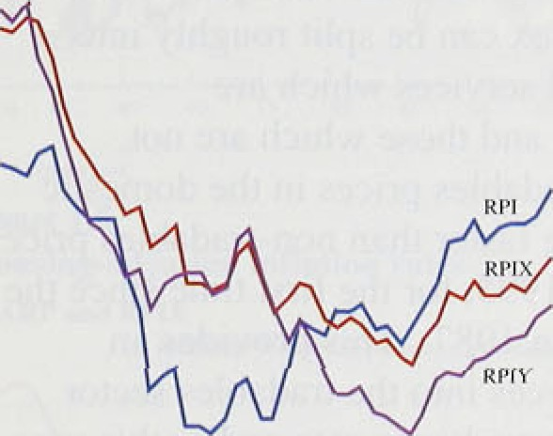

‹ ancl July. The headline rate of inflation rose from 3.57r in June to 3,.99c .in September.

Sifice the!current monetary framework was introduced in October 1992, the RPIX inflation rate has ‹ivei rided 2.8%, .compared with 7.OU in the l980s, 1. 2.6' r i n the l970s and 3.59r in the 1960s.' ' ' Althtiugh inflalion hole recently been low by histoi’ical stanflin ds, it has been higher than. in the United Kingdom’s major crnlipetitors. Between October 1992 and September 1995. cc›nsurnei price inflation in the six largest economies excl nding Hoc U.nited .K irigdom averaged 2.4%. In September. UK inflation was the second highesl among the Group of S.even largest industrialised econ‹›iries.





**Fond price arid RPIX.** inflation

.RPIY in:flatipn, which. excludes indii’ect taxes as well as mortgage interest payments. has been lower than RPIX inflation1.over the past three years. It .averaged 2.3°7r between October .I 992 and September 1995. In the three mofiths to September, twel.ve-month RPI Y ini’l‹ition increased fiom 2.3°ñ to 2.6°J (see Char i I . 1 .

rh r R l h e

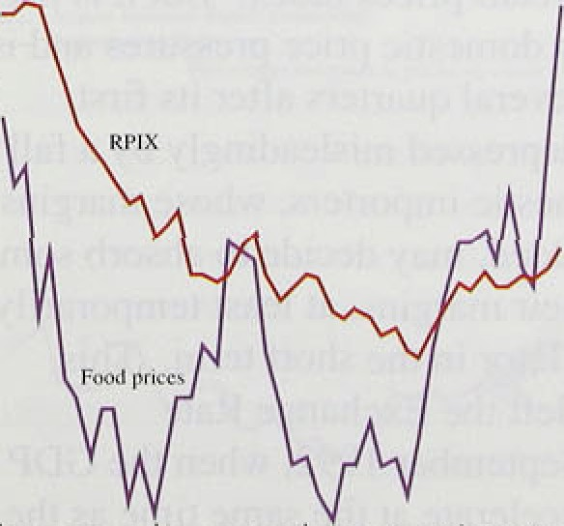

,

,

’•

,

d ene

acco unfed fo i byw beer In d' dcS ipet ho

Excluding .food prices. RPIX inflation fell from *? Syc* to ’. 2.77 There were two main .reasons for the acceleration of food .pricéh. First, ci’op .damage in the surrNner

.drought pushefi up the price of seasonal foods: annual seasonal,food price Inflation was l3.4°7r in September‘. Secon‹i, meat prices, rose strongly. reflecting a tightening

, o( supply ,cofi‹iitions in the European meat market. These1redu‹itions . in supply aré temporary and prices should fat.i “back-3s new crops become1 available in the spring' and as meat. pro‹iucers adjust their livestock herds. wi.th no!effect.on. the general price level—or‘ the 'assessment of |i:(lati;on .over the medium. tei’in.

Chart..1..2 Shows that:the .sharp increase in food price

’



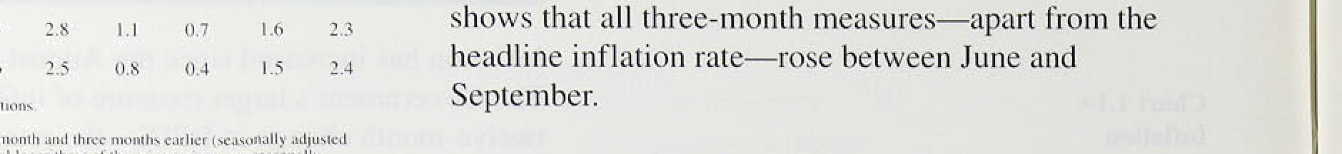

, , ,

, ,

three-.rrionth. peri’od: /Table 1.A.presents,short-run.' inflatioh r*tes., se'asona’lliy! adjusted and aniiualised:' It



1. nrt-run **inFlati‹›n**













Q2rnQl ’’0. !’’0:2. U::’

.inflatioii! in 1993.had orily a temporary effert on!.:RPIX

###### inflatioñ:

Au3l „.: Recent..pric.é developments.are .better captured. by

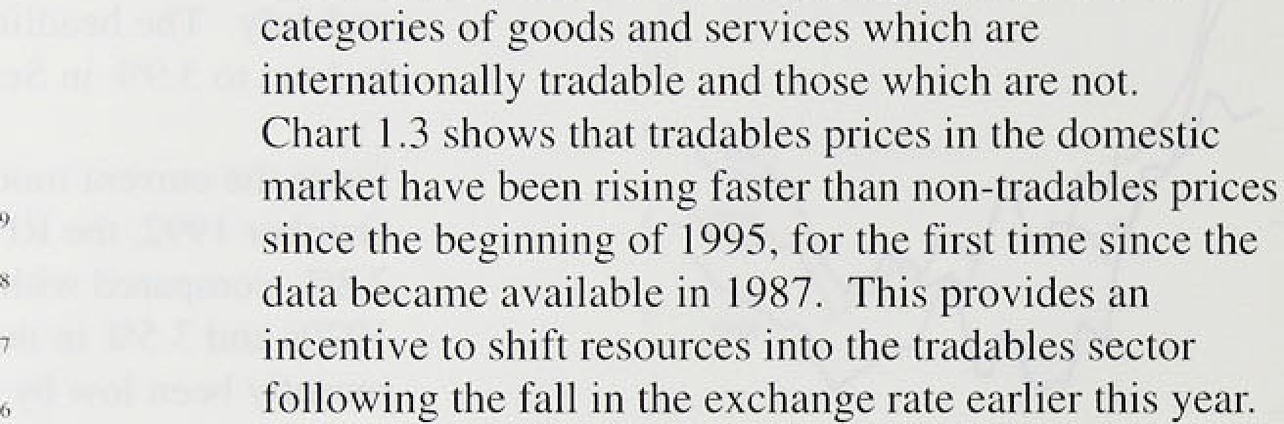

If a‹iministered prices..and seasonal. food prices are

R PI Y inflati‹›n

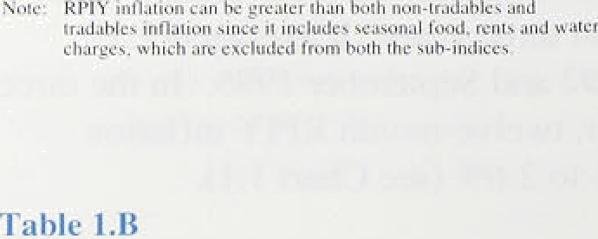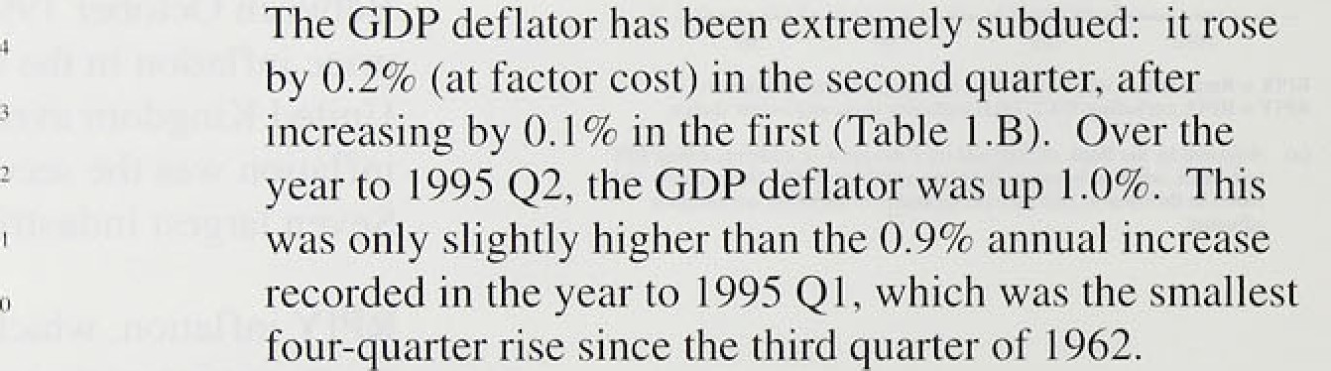

_

RPI h' ii ›n- truJ:ili1e.s

d'ecelerqfing:since!the beg.inning.of..1991..

I:ri.princi:ple,'th:e G:Dfi”deflator, which 'rñeasures thg price

**Kxyenditure deflaturs (market prices.›.**

pu:t;

.’domestically genetated”inf1'atton across tire whole

CO



prices index. :Bu:t it:is not the most ti.mely guide to domestic price pressures and is subject to revision for several quarters after .i!ts. first

###### are part of total value.added, may decide to a:ñsorb some depressing.the GDP ‹ieflator i:n the shon term.. Th:is



happened:after ster1i:rig left the Exchange1.Rate Nlechariism (ERM} temñer

deflator continued to decel:erate.,at the..same.time. as the

domestié **demand** deflâtor acéelerated.! In.1the first.haif.of



rise to that seen in tire'fi.tst half of 1993, Whi!le both the GDP deflator and the dorriestié:‹iema'nd deflator were subdued i.ii.ithel second quarter, the 0.4&. increase in the

*fti'‹•r,ir y/i•i•rlcy›iiirut.• iii ffl iiiiut*

iloinestlc, deman‹d‹ieflator was greater than the () 2*? risc in the GDP defiator. The increase in the domestic deiyianñ d'eflator is likely to give a better indication .Of the



.pressuré on. domestically-set prices, so the GDP deflator inay accelerate in the. second half of this year.

**HouSing adjuhted 'inflation raies**

'Chart 1.6..

House prices fell between March and July, but stabilised ifi the"following three. months (see Section 3). Measures

,of/inflation vihich use house prices to. adjust RPIX and RPIY for the llcost of owner-occupied housing suggest

.that inflation is weaker than indicated by the unadjusted figures. Bet lhey atso show thar it is inci’easiiig. The housing-adjusted RPIX (HARP) rneasui‘e replaces the Central Statistical Office’s. (CSO’s) estii4iatc of housing depreciation with the Bank’.s estimate of the user-cosl of‘

.housing. The THARP measure adjusts RPIY in a similar ‘way. Chai t 1.5 shows that HARP and THARP inflation have been Significantly lower than RPIX and RPIY inflation pver the past year.

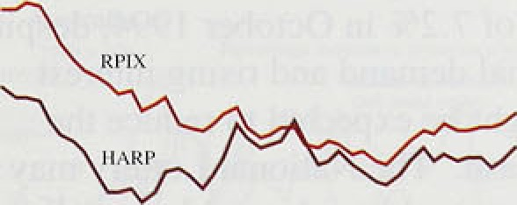

.I!ii O.ctober, twclvé-month RPIX inf’lation is likely to increase sl.ightl.y. This partly i’efIe:cts the fact that shai‘p n’oh-/seasonal food price discounting in autuiiin i 994 antl other special factors .last year will not be repe:ited this year, but also .continued increases in seasonal fot›d pi ices. RPIX inflatioh is likely to remain higher in November’.

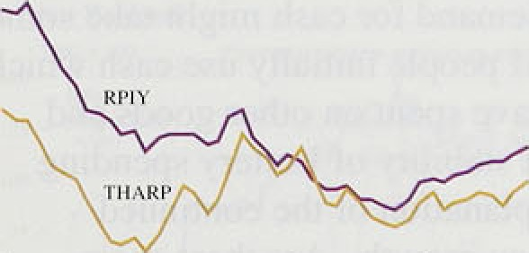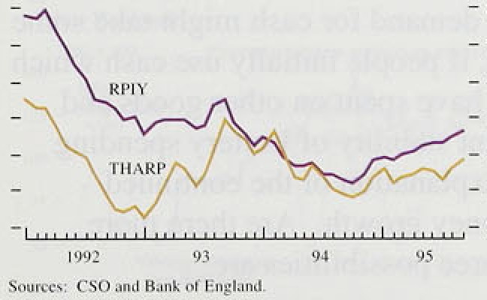

, before propping back i.n December (sec Chart 1..6). In

* clontrast, the.hdadline rate of inflation is likely to fall

‹ back .lnloetober, because of the i ecent i eduction in

' .mortgage interest payments and as l‹ist year’s inter est i'atc- iiierease drops out of the twelve-month comparistin. It is l.i!kely to;remain. lower in November and December.

# 2QS m ar

. **RPIX in'fiation- projections and.outturns'*'**



.Tw.elve-month inflation increased between June and September,..as a result.!of faster food price. in.flalion.

.Most.fhrge-month measures of in1’lation. have also risen. The faster ii creases in food prices are likely tt› be

.reversed. over the.coini.ng year. The riite of inci’ease in the. GDfi'defIator remained at tiistoi’ic lñws in the second

.quar(er, byt. it.may bang. been depressed by the

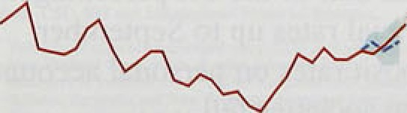

.depreciation!of stgrling.between January .ind May.

2 

Mone an t

’l’iible 2. I

( • i-i›ss t li rim es tit’ ni‹nirtars aggregates *'



h:2

*Nor.row inone v*

In the twelve months‘to October, M0. grew. by 3,2. o,..1‘ess than September’s rate of fi.5Sr and August’s 6:I &r., Excluding the often erratic bankers’ ba1ances,i however, narrow money growth.has:remained robust over.the past. three months. Notes and coin. increased.by 0.5&o .in October, broadly in line with the avera!ge monthly growth this year, leav!in.g ttte‘twelve-month:rate, of increase at 5'.7& .

Twelve-month notes and eoi:n gcowth.has fa!len. only mod’estly from its peaks..of 7.2% in Octo.beer 1994, ‹respite slower growth of nominal demand an‹i risi:ng: interestl

Se pt. 0.4 5:7 ft.4 5:7



Aug. 0.3 6.S d.7. B.1

Sept. 0-ft 8.1 8'.3 8: I



3.’6 3:3’ 3.3



7.J 5.7 1:g







rates, both of wh:ich might be expected:to.,reduce the growth in de'mand for cash: Tire National Letter:rriay still be having some impact, althou

on the on-line game. and.‘Instants’.seems to have stabilised since the spring at atound k100 millioñ. Such a one-off.shock to the deinaiid.for cash. might take some tirfie to mariifest itself, if peoplé.iñitial!y use c.ash! which they would otherwise liave..spent'on otfier goods and services. But the recent stabilit;y of Lottery sp1en‹ii.ng inakes it an unlikely expl'anation of the.conti.nuñd,' strength of narrow money grow.th: Are there'more plausible reasons!? Three. possibilities are:



1. The cost.of holding.leash relative to otlier

imerest-bearin.g:assets—the opportunity cqst has! riot i.ncreased.as much. as the iises in official interest rates might suggest. , Average interest rates paid.on but.ldi!ng s1oéiéty..shire.accounts..and:retail

ban.ks .›-'n”..s.ta!n.. t a.c. cess. accoI un“ts, whi-ch.”!m:i’g1it.be

considered close.substitutes for cash. holdings, increased by .less than:half of the l'/i pementgge point.increase.i.n ofFtcial rates up to September.

.And.in.October,.deposit rates on personal accpunts

in bans and buil‹fing snrietiei fell.

(fi.). Peopl!e,take time tq reaét to an,inctease in deposit. rates, so !the efteet of higher internt.rates may not yét have fed through.completely. .Bank.reseârch suggests that the maxi i m impact of intereetzatc changes on’narrow a:obey gmwtli is felt.azlmat«



1 year.after:the chan.ges. .Some international comparisons„tend to confirm that the demand for '.marrow money a‹ijusts slowly to higher interest

.rates. .Currency in circulation in .Canada and Australia !has increased rapidly over the past two years,..often. at rates well in excess of UK notes and cofn growth, even though interest rates were raised earlier than in the United Kingdom. But narrow

.money growth now seems to be falling in these

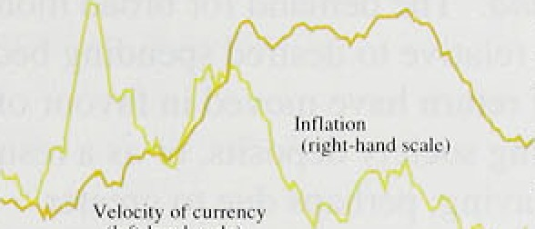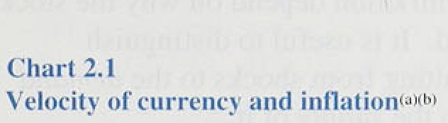

:couiitries. Moreover, their inflation rates have remained low despite fhe strong growth in narrow money.

 .People may believe that the opportunity cost of holding.cash—the nominal interest rate—has been permanently reduced because they now expect linflation to remain low, and so want to hold a

.higher proportion of their wealth in notes and coin. This will affect the rate at which notes and coin change hands—its velocity. It is not clear, however, whether such a change would shift the levef of narrow money velocity (generating a temporary

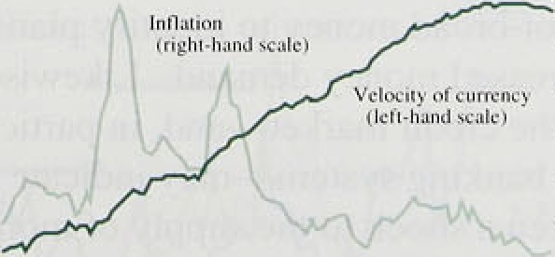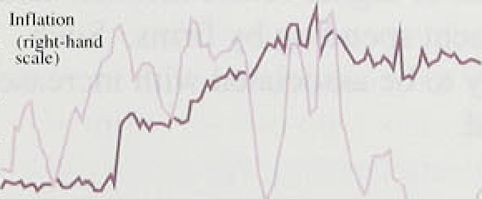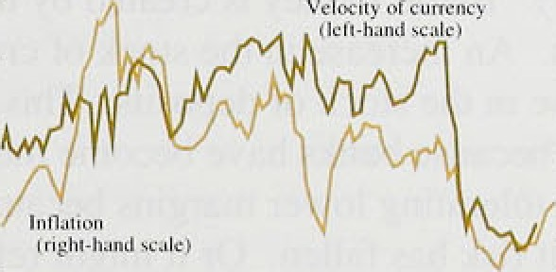

.effect on narrow money growth) or its *growth* (a permanent effect).

„Exidenee for the United .Kingdom suggests that there rtiay be a positive link between narrow money velocity growth and. inflation. Low inflation in the 1950s and

.l9ti0s was accompanied.by relatively low growth in

.velocity. In the l970s and 1980s, high inflation coincided with:a pick-up in velocity growth. Over the past few years, both velocity growth and inflation have

,fa!len. !n several other OECD countries, a fall-off or

:f1attening: in velocity.has coincided with improved

:inftation performances. .For example, in New Zealand this sliaried towards the end .of the 1980s, and in Canada and Australia it was most obvious after 1990 (Chart 2.1 ).



inroad.inqney has continue‹i’to grow strongly. although it is..,np longer'aecelerating. Iri.the twelve months to **September;.M4** gfew by 8.2 'o, slightly less than the rate

well above the 6.89c in, June.



Short-run:measuies.fell .in September, although both the three and six-montlJ! an.ñuâl1se‹i .rates remained above the twelve-month rate;, in'the.,tnree months 1to September, M4 by .s& a:than anriualised ratti, co"mpñred with **10.49'r** ifi.August. Moreover, because of the:s:mall ipwease in M4 last October, the twel:ve-month growth





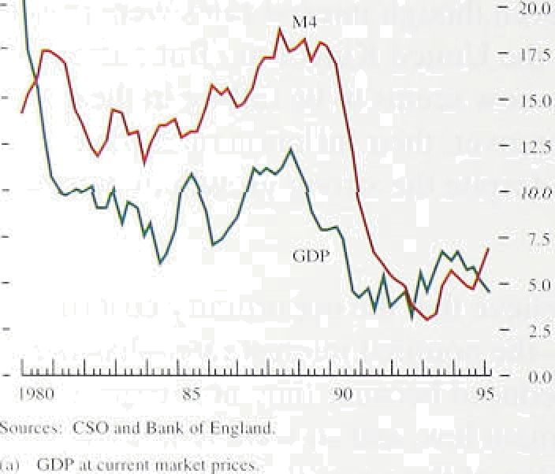

’l’ii hle 2.11

**Cliiinges in 4l4‹°'**

ICCs OFIS. Toral,







1():

.For most of the l.980s, brpafi money g w much faster thafi nominal GDP .lñrgeIy reflectin!g. financial’ liberalisation. S!nce t1ie.early 195.0s, the.!re!ationsh!p. between M4. growth arid fioinirral actively !bas beeh› considerably closer.. Howe.vñr, i,n'.the:.r ecenf past tliey. stai’ted to di.verge again. in:the:year to:the second. quarter, M4 growth at 6:8% was:'much’strongér than nomi.nal GDP growth .(Chart .2.2): The.i.mplications:for

.nominal spending. and.inflation depend.oii. wh.y the stock of money has increased. It:is usefu.l tq:distinguish between *.increases .resulting rom shocks lo:*th*eede*zn*’ and* for money and those to the *.sufiPl.y* of it:

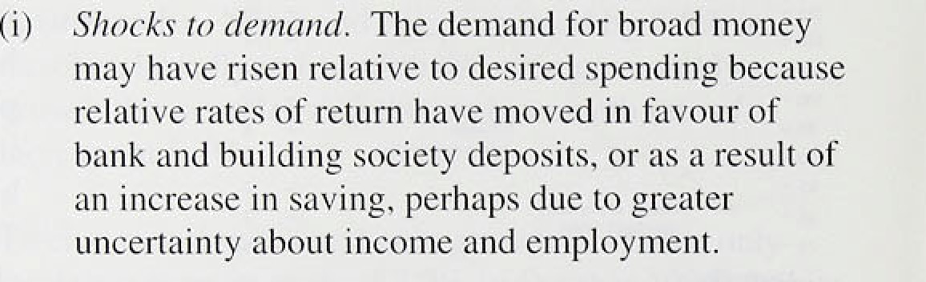

1. *Shocks t.o suppl5!.* Broa‹i.money is create‹i by the, bankin.g system. An increase: in the stock o.f.:credi.t! can. lead.to a1.rise in. the stock.of.‹deposits.. This .rriay have happened because banks:1iave become more willing to lend, tolerating,,lofier.margins ‹because' they.think credit risk .has fa!!len. Or it.might reflect an increase .in. t!he d‘eniand"for:credit. associated with explectatioris.of'hi.ghér faturé incomes aqd. planned investment spendin!g’by firms.! S.uch shocks .are li.kely to .be.associated with .iricréased nominal..demand.

Empirical evidence.suggests that:the/deinarid for botti

.money.and eredit1varies:according to the type:of econoiriic agent. .it is therefore useful to.look at the sectoral brealiii:iwn of ñyoad trioney to identify plausible explanations .for.increased! money demanñ„ Likewise. a sectoral anal.ysis of.the credit m ket and, in panieu.lar, the behaviour›ofi the banking 'syste/rñ may’ iñdicate w1iether.t!here his.been a shock to the supply of ;money::





:i:ncrease .ih M4 between December:.and September was ifi\‹ieposits.of indiViduals, which account .for around 60S• of the stiock of M4.and around. 909a of the. personal seétor’s’M4.( The.remainder of.the increase was, largely ac‹iounted (or by the deposits ,of,other finañcial

institutions (OFls) wh.ich:.held. around 20% of the .stock





. of M4. OFIs’ deposits rose by £16.3 billion in the

:period; significantly.more than thei.r increases in rhe. ca!lendar,years 1993 and 1994. The deposits of industrial and commercial companies (ICCs) have grown much *m*ore.slowly and, in the. second quarter, were run down— before being. built up again in.Q3.

Individuals deposits have accelerated over the past year an‹J rose by a .further £7.6 billion in Q3, compared with

£6:.7 billion.and fi4.7 billion in 1995 Q2 and QI respectively. £1..8 billion of this rise probably renected the payment of bonuses to deposit holders with the Cheltenham & Gloucester Building Society, .following its joining the, Lloyds Bank Group. It is not clear how far the i!ncreased deposits, reflect a genuine increase in

long-term desired money holdings. or how far they have msulted from a shock to the money supply. The sharp rise in personal income in the first quarter may have led to a témporary rise.in personal sector deposits, which will bg..run. down to finance higher nominal spending on goods and services and financial assets.

Bul i!ndividuals may want to continue to hold higher levels of bank and building society deposits over a longer period. Given the uncertainty over employment prospects„households may have increased their precautionary savings. And the recent fragi.lity in the housing market may have discouraged their from tying

!up their wealth in il.I.iquid assets. This process may have been reinforced by .changed mortgage lending criteria requi!ring pFospective owner-occupiers to save up larger deposits for house purchases.

 'The well.-pu.blicised take-overs in the building society sector may also ttave been a factor behind the rise in

"' I' .in‹ii tdual deposi.ts. Some investors have increased their

. .holdings,.in. such:accounts so.as to qualify for bon.us paymeritsl.or.shares.in the event of future take-overs.

Predominantl from household Account holders, have risen significantly this year. **Tire** average monthly inflow up to September—



**ex0luding,interest.pai‹i was** fi0.7 .billion, compared with 20.2.billion iri. 1994. This:seems to have occurred at the expeñse of oifier types.of financial assets: flows into.

 not trusts Fixl na:tionat savings1.in the first nine months of

.the'y.en w e less ttiañ liaif ofi.their level in the



**coNsponding** peri d last year (Chart 2.3). But

.individuals’ battk deposits have. also risen rapidly in

inflation Report: November I '905 '

motive can be,. at best,. on.1y a.partia!l explanation. of.the: increase in persona:l sector deposits,

After growing strongly during, 1.994, ICCs' M4 deposits have been more subdued .in 1995. In the year to Q3, they grew by 2.3% compared with..oxer 10 : in..!994.

The fall in the. second quarter was. not.:repeated.in the: third, but the rise was only.modest.

Most of the rise in non-personal sector deposits so far this year has been attributable to OFIs. As OFIs are the marginal source of .funds. for the banking system,/th!is may simply reflect.liability management by .banks which finance increased lending initially by bidding: for deposits from OFIs. However, OFIs may be holding more money in. bank.and.building society accounts than they desire in the long .run, perhaps beéause they are uncertain about returns on other assets. ,Even so, it seems unlikely that these excess deposits, will be used to finance increased future expenditure on goo;is.and SeTvices, sinee the finaneial,sector's. holdings of asse!s depend largely on relative rates! of return. The rriain counterpart to the strong:.g wth. in..OF!s’.deposits this year has .been their reduced take-up of gilts. Between.

April and.September, the M4 private sector bought

£6 billion of gflts, compare,d with over E13, billion in the same period last year. .If OFIs user their deposits to buy gilts later .in. the year. !he effect could be .to reduce aggregate M4.



Bank and building society lending(') is no longer accelerating, although its. growth remains high:. Taking the.third lquarter as.:a whole,.lending grew .by 2.09•„ broadly comparable with the rate of increase. in the,.fi.rst. half.of this year. .In the'twelve months to ’September, it grew by. 8.lie’.

OFIs'.borrowing.increased.ñy a further. £3.:4 billion. in the third quarter—a.larger increase.than Q2's

£2.2 bil!lioli.. The .increase..occurre‹i ‹respite repayment of

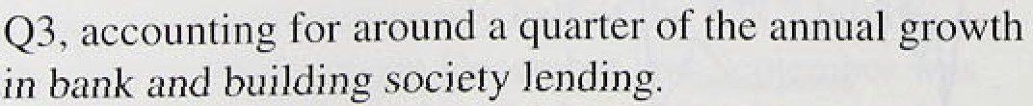



quarter. .And .len‹iing was depressed in Q2 (by around

. fi2lbiIlion.) and Q3 (by around fi I bil.lion) by the repayment of debt taken out in Q1 by Glaxo. Lending to ICCs stood .at fi138 bi.lI1on in Q3, I O.59 hi:gher than a year earlier. The increase may have ret’lected a greater desire to invest1 in. fixed capital. Nomi.nal investment spending .by manufacturing firm.s in the .second quai ter was 16.8% higher than in. the same period a year earlier. And the sectoral breakdown of lending shows. that bank lending to manufacturers (excluding the chemical i.nñustry, lending to which was distorted by Glaxo’s

take-over of Wellcome) grew by ;iround 1*/c in the year to the second quarter, ihe first i’ise since 199 l Q2. Data for the third quarter suggest that borrowing by non-chemical mari.ufacturers strengthened fur ther.

**Char2.4**







Some fi.rms, however, may be! borrowing tO sustain cash flow Grid finance the invol.untary build-up of’ .stocks

!resu1ting fro!n weaker-than-expected demand. Stocks i.hcreased .by £4,4 ñill ion (at current prices) between 1 994 Q3 añd 1995 Q2. In manuf;icttiring, foll‹›wing a tightening of monetary policy, intermediate and small- scale.producers of durable goods tend in the shoi‘t i’un to borrow more from banks than do larger firms to sustain cash..filo.w. But sectoral lcnding data show that lending to ‘either ma.nufaeturers’—predoin.inantly small firms— accounti.ng for almost a quarter of’ total bank lend.ing to

:rñanufacturing, increased by only l.97r in the year’ to the

/th!ir‹i!.quarter.1 The largest increases were in lending to mptor vehicle. .mechanical engineering and food, drink and tobacco .manufacturers, which are likely to be large

.firms,., Moreo.ver, .lending to .firms in the service sector. where. output %rowth has remained i obust in l99ñ, strengthened noticeably in the second and third quarters. So cash .t low seems unlikel.y to be the explanation.



'!!"°- .• A.nother possibility is.that .firms .have been borrowing to fi:nance more coiripaiiy acquisitions. Again. however. the

— " :eVidenee is not compel.ling. Apart from Glaxo’s take- over of’We1Icome."wh.ici1 occuri‘ed in the first quarter, the

' value of casii-finaAced' acquisitions and mergers within

_ , the Uni.te‹1.K!ingdoin!increased only modestly over’ the

.first.hal.f’of this year. !And thg. total iiuicber of take-over

, and. merger transactions has fallen back (see Chart 2.4), Bu!t overseas acq.uisitions by UK. companies have

— ' ..i.ficreased this.year; .with’ funds!predominantly . raised through the UK acquirers;. which could account for some

" of the i.ncrease:in Frank borrowing.

ike Unilcd X1ngdom. IncIv‹kc fin\JnniitI



ICCs may be switching to.:bank finance trom otlier sources:of funds. Internal fiui:ds hiive continued to. grow.



l:ihIc?.t'

**ICCs ’ sources** of' 1’unds‹ " '*""’









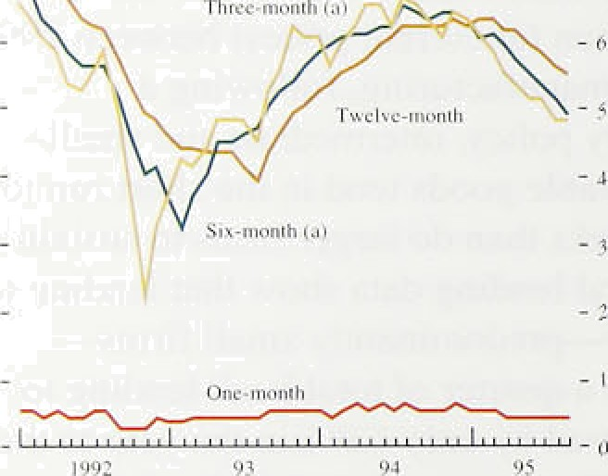

**”1”rendv in bartk BFId huildiiig snciet¿** spreads

I’m rccn u c h;1:In;* i a y





- 2S









14

but at a much slower pace: ICCs’ retained earnings were 4.9&c higher in Q2 than a year earlier, compared with average annual growth of over 25% in 1994. ICCs’ net sterling capital issues have also fallen: they averaged

£0.7 billion a month between January and September 1995. compared with £1.l billion in 1994 and

£1.3 billion in 1993 (Table 2.C). This decline occurred despite a significant increase in equity prices this year compared with last, which might have been expected to encourage greater recourse to the capital market.

Lending to the personal sector by banks and building societies decelerated a little in the third quarter, increasing by fi5.4 billion in Q3 compared with a quarterly average increase of £6.3 billion in the first half of the year. The fall largely reflected borrowing for house purchase, which increased by £3.8 billion in Q3, compared with £4.3 billion in Q2. However, loan approvals stabilised in the third quarter—driven largely by banks, which recorded approvals of £4.4 billion in Q3 compared with fi3.8 billion in Q2. Lending for consumption has remained robust; it increased by

£1.3 billion in the third quaner, broadly in line with the quarterly increases earlier in the year.

The broader measure of borrowing by the personal sector—including that from specialist lenders, as well as from banks and building societies—was also subdued. Total net personal borrowing increased by fil .9 billion in September; the twelve-month growth rate has now declined for four consecutive months (Chart 2.5).

Shorter-run growth measures have fallen for longer. Within this total, consumer credit (unsecured personal borrowing) continued to grow strongly, at year-on-year rates of over I 09o, although It was no longer accelerating.

*Credit stiypl )•*

Credit supply, as well as credit demand, is important in determining overall borrowing. The narrowing of spreads suggests that banks’ willingness to lend has increased over the past year. Average spreads between loan and deposit rates fell significantly in the first half of this year for both industrial and personal customers. A sharp fall in the spreads reported on syndicated lending, which are now at the lowest levels since 1589, may also help to explain the increased lending to ICCs this year. The latest CBI Financial Services Survey reported that average bank and building society spreads continued to narrow in the three months to September, as they have for well over a year tChart 2.6).

UrJiir'\' riiii/ rii'/‹'rr',s/ i’r//e,i

The .narrow ing. in bank spreads may be related lo

‹developments in banks balance sheets. As ltte i ecovery has:.proceeded!. ’the fricidence of bad debt.s has fallen.

Indivi.dual insolvencies. fell from ther.r peak ot’ ui tiund l0,00Q in the first quarter of 1993 to around 7,00() in

.1995 ,Q2.. Company i.nsol vencies, .too. havc fallen sharply—to a ley.el broa‹ily comparable with the



mid- I98Us. This has led to a reduction in provision.s and higher reported bank profi.ts. To the extenl that lhese have been retained, they have enabled bank reserves to be .built up. .ln 1994, retained ear nings for lhe l.ii’gest mine .UK b3nks i.ncreased by £3.3 bill itin, accounting for arpund 859a of the rise in their combined net capital.



Wi!th.,the risk-weighted assets of these banks growing much more slowly, their combined i isk-adjusted capi ta1 Asset ratio.rose to l I.4*Zr a1 the end ot’ 1994. well above ld?els at the.beginning of the 1990s (Table 2.D).



**Tabléi 2:E**

**Top 20 b.uildiiyg pocieties‹*'**

’ 0.p<miing prcifii’s.

’

‘B.u.ildi:ng societies. too, have .enjoyed higher profits. The

!suiylus of the top 20 bui.ldi.n.g societies increased in 1954, .riSing. as a proportion of reserves to 13.6Ur, l’rorn

’‘ 12:S% in l!993 and l l.27c in 1992: With asset g•rowth relati.vet.y modest, the .ratio of reserves to assets has ’iricreased.(Table 2.E).

The key q.uestion is how rriuch this inci ease i.n c• Fital hits

.led banks .and lbuilding societiés to exp‹uid their’ balance sfieets.: If banks.are wil.li.rig to cut their margins turihei’, stronger credit growth and in turn stronger demand growth may ensue., But there are signs thal banks may choose to. return. some o.f their.excess capital to thei.r sh’areholders; orie high street bank has alread) embarked on a.share buy-fiack.

To sum .up, lhere has probably been a one-ot“t ups ai‘d shift in...the derriand for bi oa‹i money, although ii is uncl’ear how .enduring this effect .will be. .But the recent strength‘in broad money.gJ’owth also reflects an increase ifi US siippl.y! of money; as. a result of both an increase in. the demand for and a.greater willingness by banks to supply credit. , The'risk‘ in OEIs’ deposi.ts is 1.ikely to have fewer:i inpl.icaiioiis for.inflation, st.nce OFls often switch.



.! bi:fciré'.baii!debis

Chnr¿'c 'for dofresliv . '.' had '.And'iioubif ul:debis',

.assets w|fhi.fi their.portfo.l.ios witfi .little etfect on the real

.economy. The bui'ld-up .of pejtsrinal sector deposits may be less bénign: .If people. decide to reduce’.liqu.idity partly. by runn.i.ng .down’‹ieposits to .buy goods and services; nominal spendi-nq• will.. accelerate, which could

.lead:to higher prices. ..Eveñ'if this does not. happen. nominal demand may still.i:ñcreise faster..if hte sirong growth i.ri:credit persists. ICCs seem l!ikely to:.continue



iis einfrcr 99S



economic recovery matures, despite the weakness of demand from the construction sector (see Section 3).

* •' ‹ This is particularly likely if banks continue to lend more willingly, trying to earn greater returns on their currently high levels of capital.

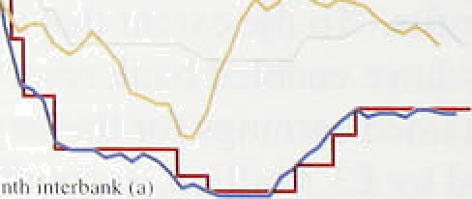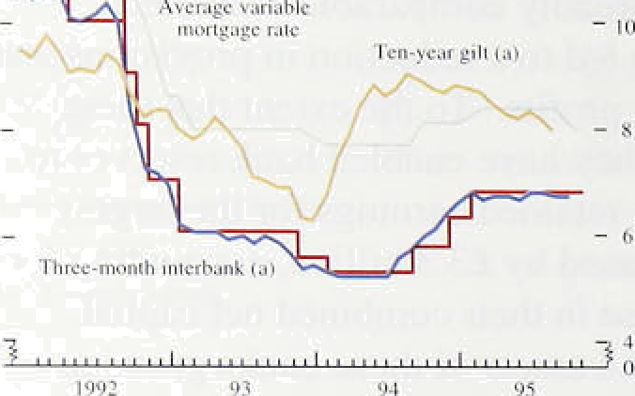

'"

-



Divisia measures of money, which weight the various components of M4 according to their transaction characteristics, may provide some indication of whether the increased money growth is likely to be used to finance greater spending on goods and services. The Bank’s Divisia measure rose by 6.49 in the year to Q3, compared with 5.4% in Q2. This is a notable pick-up in growth compared with 1994, when the annual rate averaged 4.6%.





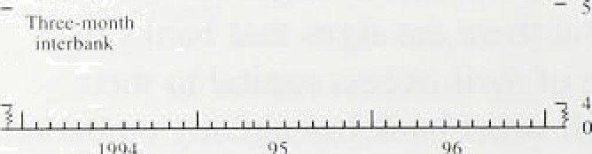







14 -d:iy repo riilc I› Sepl. -10 4.20

Oftii:ial di Seen n i rate S Svpt.  24l›‹•ur rep‹› raw ’J Oct. + | 10 7.2'i





The acceleration in Divisia money in 1995 is more marked in the personal sector. Personal sector Divisia rose by I .7°Zr in Q3. to bring its annual growth rate to 5.49n. its highest rate since 1990 Q4. This suggests that the build-up in personal sector deposits is likely to tinance higher consumer spending, although the relationship is volatile. Corporate Divisia money rose by 9.7% in the year to Q3, compared with average annual growth of around 11 % in 1994.

#### 2 Inte est ates d e han e r tes

Since the August *Report,* official UK interest rates have remained unchanged at 6.75%. But market interest rates are now generally lower than in August. Chart 2.7 shows some of the interest rates paid by different borrowers or used as a basis for calculating their borrowing costs.

Futures markets have revised down their expectations of UK interest rates and now expect them to fall slightly over the next twelve months. Rates on LiFFE’s December contract fell from 6.98% on 28 July to 6.64% on 3 November. They dropped from 7.11% to 6.49&• on the March 1996 contract, and from 7.31 % to 6.51% on the June 1996 contract over the same period (Chart 2.8). But interest rates are then expected to increase.

These interest rate changes have coincided with similar developments overseas (Table 2.F). Official interest rates were reduced by 50 basis points in Germany on 24 August and **in Japan** on 8 SeptembeT, and these moves have led to widespread falls in both current and expected future market interest rates in those countries.



tihart2,S.



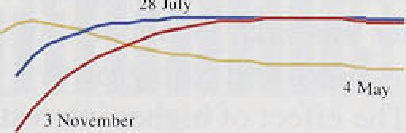

- - i





Ciiart 2.10

**Sterling. exchange rstes**



”2,3£ -','

3:54:-.::

:*2.32. .::

'

All major,UK lenders.cut their variable-rate mortgages

.by ar'ound 35 basis points in September. The weakness in the housing market was the reason most often quoted for the cuts, but the fall in the.cost of attracting funds—

.both on retail and wholesale terms—also seems likely to

!have1.1been a factor.

lThe inflation .expectations implicit in gilt yields

.(abstracting from risk premia and other measurement problems).have fallen further at the three-year horizon— the.shortest maturity at which they can sensibly be lestiinated—and are now around 4%, compared with 4.Sh at the. ti:me of the previous *Report* (Chart 2.9).

Longer-term yields have also fallen since the August *Report,*.although. much !of the movement has been concentrated at shorter maturities. UK ten-year bond redeinption yields were down 30 basis points between 2:8 July and 3 November. but.overseas rates at longer maturities have generally fallen by more than in the United liingdom. As a result, the tendency for interest rate differentials with the rest of the G7 countrIes to inerease has .continued.

The change iii UK yields over any period can be decpimposed into the changes in expected real interest rates and in expected inflation over the same period. although tfie division is affected by other factors. such as term or uncertainty premia. The average real interest rate expected over the .following ten years fell sharply

.after 128. July, ñut this was reversed over the past month.

.Similarly, ten-year inflation expectations, after falling

:back in Aug.ust and September, increased quite markedly



.1n!’October. But oñ 3 November

ten-year hori2on stood at 4.9%—broadly consistent with lei'el« at the end of I.uly, but around 50 basis points



.higher than at the time of the May *Report* (Chart 2.9). This deterioration in expectations .suggests some erosion of,long-run .UK .monetary polfcy credibility.



.Comyared'ivith its level at the time of the August *Report,*

. Trade•eig@ie.d'ia&



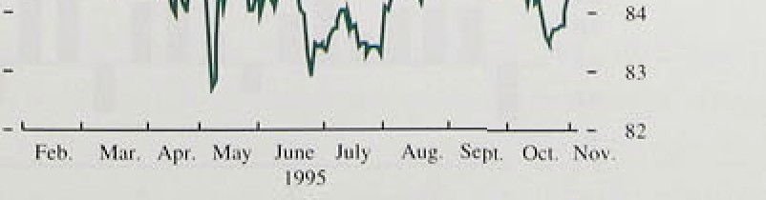,(Ghart 2.10) above.tire lowest points seen in the late **sprtng** and.Sutiuner,! but still around 6% lower than its **average oder the.** l8imonths .before it started to depreciate



Sterling has. strengthened.a 1:ittle.. But larger gains in

reversed in .October.





1 S*GonRtQoi‹: NowniMr ñ105

Chin t 2.11

t.!K effective exchange rate profilesi•›

s 1-riu›ni h

° ii• mini itli u ^ - iii Auth

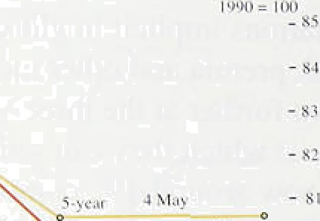

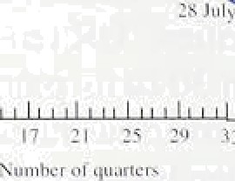



###### .reversed quickly. This view seems to have been Frome’ .

!out. Chart 2..11 shows the exchange.rate paths implied over.!the following ten. years. one 4 May,.:.28 Juty. and

3 November if interest rates adjusted•..fir,expected exchange rate changes are equalised (‘uncoyi›red:interest parity’). Compared with.the.August *Re!port,* the'futu!re. level of the UK rate is! ñow expected.to be.sl.i.ghtly.higher: over!a ten-year horizon,.1.although still below.the..!evel expecte‹i in May:

2 3 S

Measures of both narrow an‹i broad!rfioney:supp1y.have continued to grow strongly over the past three mpn s, MO grew by 5..2To ifi the. year to. October; sl.i:ghtl.y less ! than rates recor‹ie‹i earl:ier this: year„ Stripping out bankers’ balan'ces;. annual notes añd:coin .groivth.’ remained close.,to: 6&•. The effect of higher.interest rates msy not yet have fed *through,* !,But a move\to a

low-inflation environinent may meal that,a larger proportion of wealth will be he1ñ.i.n: cash. The.reéent strong: narro.w. money growth may be part of this adjustment.and.,.sp need not!.signal higher.future inflation.

.Experience.overseas provides some support for this

###### hypothesis.

:M4 growth.has increased! in 1’99.5—to an! annual rate of 8.2âo in: September, close to the top .of: its 3,S•—9.% mprtitoring. range.. It is probable.that botli„the.dqinand. fOr atld supply of broad moqey at any. given' interest rate

.have increased., The shock to the supply of money .

###### reflects.ñoth iqcref s demo d::for and supply of t,.

i

###### e incre a

t

###### in suppryus sus i d d ho

d

###### th ‹iepesi

built, up over the.past ninq months are used. . ’

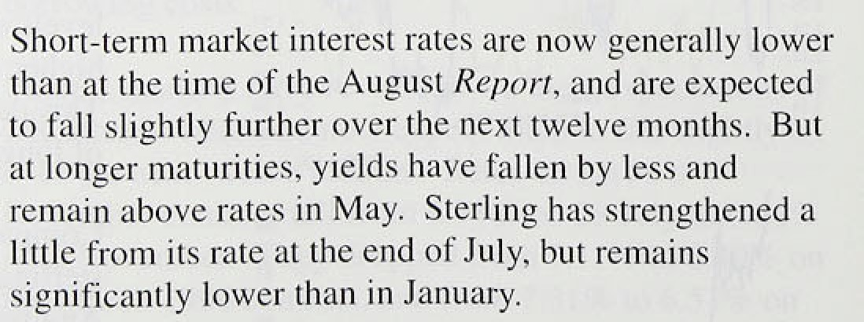





• ‹.•›’

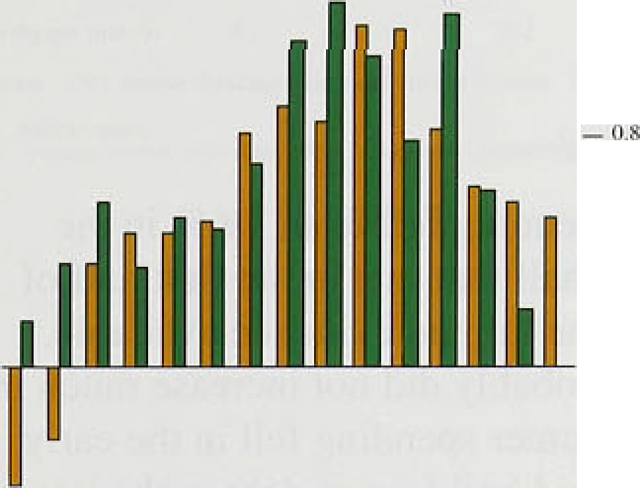



**’Cliart3.2.:**

**GDP growth.dunng three.recoveries**

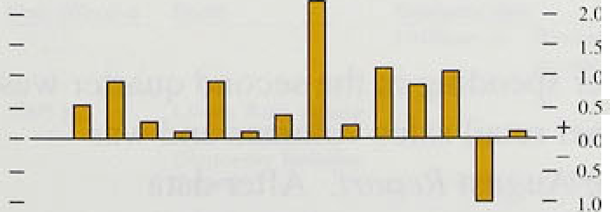

.Growth in:total demarid—measured by total real final expenditur fell in the. first half of the year. Chart 3.1 shows how demand growth picked up sharply in .late 1993; was high throughout 1994, and then slowed to around the same rate as at the beginning of the recovery in **1992.** Total domestic demand (total final expenditure less exports) followed a similar profile.

Output growth slowed in the first three quarters of 1995;

!in the third quarter, GDP rose by 0.59c. Since the previous *Report,* estimated growth in the second quarter has.been revised down by 0.1 percentage points. In the sgcond.and third quarters, annual growth in GDP and non-oil GDP were around their long-term average.

Qqarferly..GDP growth so far.this year has been less than

.i.ii.each quarter of 1994.

The United Kingdom is now in its fourth year of

.recove . A feature of the recovery to date has been the remarkably smooth profile of output growth, with quarterly growth rates of total and non-oil GDP showing g ater stability than in previous recoveries during the past 40 years hart 3.2 compares the latest three.

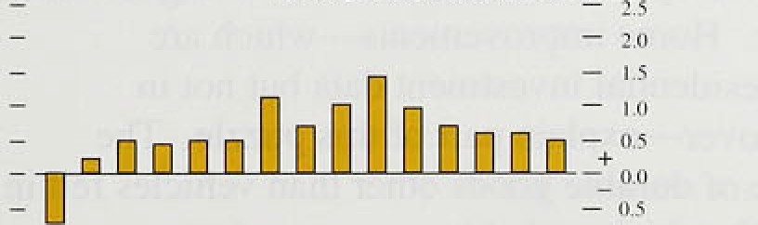

Doing this .recovery, the standard deviation of the quarterly. percentage change in GDP has been 0.3 'percentage points, lesslthan half its level in each of the

,previous/two recoveries. .So the *slow6awn* in growth this year is by no means unusual during a continuing

.re.covery.

omfnal GDP.rose by 0.7% fn the second quaner and was 3.8&• higher than a year earlier. Over the past

40. years,.real!GDPgrew by..an average of around 2'/i% a

.year; with the Government’s inflation target of 2'/i% or 1ess, the appropriate long-run.nominal Income growth rate would be around Sir a.year. .As Chart 3.3 shows, it fell belqw that rale in.the second quarter. By contrast. the growth rate. of total nominal final spending was roughly unchanged!from they. beginning of 1993. An

**on.in** spending on imports.acc:ounts for the

**C**

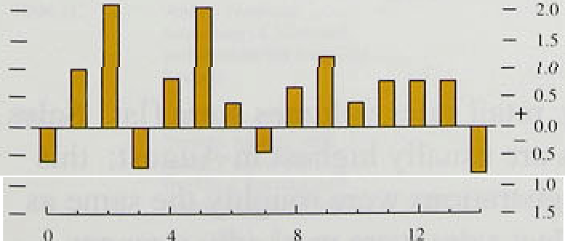

 **Dorñes?ic demand**

fi **mast1cbecIanii rose** in the. second.quarter aAer.a



fulfill ton Rctiuri: Ntiveinber l99ñ

consumption and investment rose, and stockbuilding also made a large contribution to growth. Excluding the alignment adjustment, stockbuilding was equivalent to about three quarters of one per cent of **GDP in Q2.**

Table 3.A shows recent contributions to **GDP** growth '° and illustrates the volatility of stockbuilding and net

trade in the first half of this year. Because of this

' volatility, changes over six months provide a better

*,* illustration of trends: Table 3.B u.ses *such* measures to show how growth in GDP and domestic demand slowed

, down.



, „p '" Growth in consumer spending fell from I 'h7o in the second half of 1994 to half that rate in the first half of this year. Judging by the limited evidence available, consumption growth probably did not increase much in the third quarter. Consumer spending fell in the early 1990s following the rapid build-up of debt in the late 1980s. Over the past few years, debt has been stable relative to income, while income gearing has fallen.



2.2 -0. I 0.fi



1 9



* II.l

I .0

G I've rrHiicni I l.l 0,7 — -0.G



I: tJf• :u fncto r cos i ?.2 3.0 0.fi 0.â

t.. i Qu.i r4cr lj oiHi1]n ju i t›iis :i re re l:u we tr" the prey i‹ its ‹]uuiic r. Commute ni.s





1.8 2.0 2.4 2.o i .4 1.2 f.1



? 0 I .9 l.l 1 2 1.1 11 8





Growth in durable goods spending held up in the first half of 1995 despite low housing turnover. Private residential investment has risen more quickly than house sales since the start of the recovery—in Q2, residential investment rose by l% and was about 2'/i& higher than a year earlier. Home improvements—which are included in residential investment data but not in housing turnover—explain part of this puzzle. The relative price of durable goods other than vehicles fell in the year to Q2, which probably encouraged some spending. Spending has been financed partly by consumer credit, which grew strongly in the first part of the year.

The rise in consumer spending in the second quarter was consistent with higher retail sales volumes and was foreshadowed in the August *Report.* After data revisions and reclassifications, recorded retail sales volume growth earlier this year was a little stronger than at the time of the previous *Report,* and rose 0.9% in the second quarter.

In the third quarter, retail sales volumes were flat. Sales of new private cars are usually highest in August; this year, private car registrations were roughly the same as in August 1994. Fleet sales were markedly stronger,

( I ) The box on p«gc 24 of the May Reporf discussed Lho alignjTisnt

**adju8tm8nt.**

2‹ in‹iiir r/rir x'ir/i/i

.partly b:ecause of.changes .i.n VAT i’ules for leasing companies which. took effect .from I August. As in 1994, ther e were registrations by manufacturer s and car dealers min August, though it is not clear whether they were more widespre'ad than. last year. And in Q3 as ii

.whole, private car registi’ations were I ittlc chan.ged sorripared with a year earl.ier.

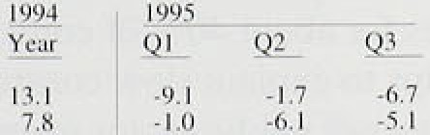

.House prices, ineasure‹i by the Halifax index, rcll between the second and third quarters, as dJd housing turnover (seelTable 3.C). Nevertheless, some stab.il Qty may have returned to the market more recently: house prices rose..modestl.y .in e‹ich of August, September and October. Cuts of about 0.3ñ percentage points in mo.st var.iable. mortgage rates were announcerl i.n .September. But.deman‹i was still held back by many oi’ the t’actoi s

.identified in the previous *Re tort:* uncertainty aboiil employi;ient; tax and i.ncome suppor change s which increased housing costs: and adjustment to a

low-inflation environineni in which ht›uses are bought rn'aifily for the service. they provide—livi rig sp‹ice— rather than as an investment. All these factors mean th:it the housing .market is probably adjusting to a new equilibrium .and that it is go.ing through a period of "price discovei’y ; lower turnover’ dui ing such a period is not surprising.

**Potentlul ‘it'indfalls’**





G lo'ucé str: r''Building:





Building Socieiy sid.







The loutlook for consumpti.on depends on expectations about .future disposable income. In the fiscal years 1994/95 and 1995/96, personal taxes increased by the equivalent of about l.'/.°7r and *'/•"% or* personal disposable incoirie respeeti.vely. The tax rises were part of a

! edium-term budget adjustment, so they are I ikely to have..been perceived as per inanent and thus to hav'c reduced consumer spending. Some i etailers did riot pass on the indirect tax inci eases in t’ull, which will have

.lessened their etfect. Consumption has adjusled to the



p

•tt+•. l› .two B,u0gets of .1993 and .is likely to return to growth at around .its trend rate over the next year’ or so..

.But greater job insecurity raises the perceived volatility



.of,future. ‹disposable .income, an‹i nay have increased

‹desired'.levels o.f liquid assets ftir pi’ecautionai’y reasons—see Section 2. II’ so, consuinpti.on would be



,. 1996 H2.

.hel‹1 back. temporarily whi.ie savings were built up.

Other’factors which will affect consumption include:

.real interest:rates; payments' following. bank and

!:building soci'efy. mergers and convérsioñs:to plc status: rebates from electricity .corripaiiies;: and, perhaps, TksS A accounts..maturing.in 199d›, Table 3..D shows. the! poteñtial siz’e of soine of the. bank arl0 building society



**The UK construction industry**

Construction output constitutes about 7% of GDP, and more than half of total investment is construction-related. As Chart 3.4 on page 23 shows, non-residential construction investment fell in the three years after the trough in GDP. The sector therefore accounts for much of the weakness of aggregate investment during this recovery. This box reports recent developments in the construction sector and assesses their implications for total investment.

The construction sector is not homogeneous; it encompasses the private housing market, the industrial, office and retail sectors, and public sector investment. Total construction output fell by about I 5°% from its peak to its trough in the most recent recession; Chart A shows that this was about the same fall as in the previous recession. But, in contrast to previous recoveries, output has not grown by much since the trough in overall GDP. One reason is that private sector construction output grew very strongly in the mid to late- 1980s and, as a result, there is still much excess space in completed commercial buildings. According to Weatherall Green and Smith, for example, vacant office space in the Cily of’ London had fallen by the second quarter to below its peak in 1992. but was still much higher than in 1989.

of this year. The Building Employers’ Confederation reported that only 27a of firms were working at full capacity in **Q3, compared** with around 50h in the CBI’s manufacturing survey. Low public sector activity, which accounts for about 40a of construction output, also helps to explain slow construction growth this year. Overall public sector investment fell by nearly 89c in the first half, and last November’s Budget projected a fall in real public sector capital spending between 1995/96 and 1997/98.

Excess space, in the form of existing buildings, and low expected returns have affected private sector investment. Chart B shows how total construction investment boomed in the late 1980s but has been flat since 1992; and Chart 3.4 on page 23 shows how investment in building and works was the weakest component of total fixed investment during this recovery. By 1995 Q2, the rest of investment had increased by the same amount as in the two previous recoveries.



(’lvii i 1 . t

t'‹›iLst l tit liii n i›ut tiul ‹ix ei I he ‹ i cfc

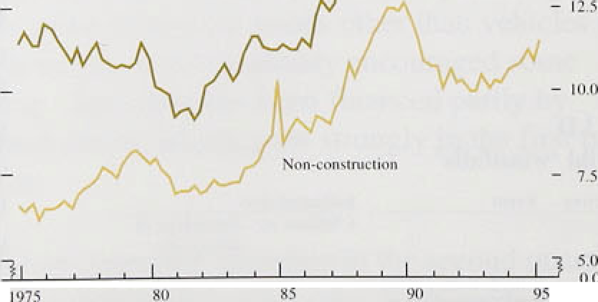4'i '' el i n Gtir - I ill i

 

* The outlook for construction investment is depressed, so overall investment is likely to
* continue to grow more slowly irl this recovery than

„ in the previous one. Overall price pressures in the construction sector are still low: the deflator for building and works fell very sharply in the early

— 1990s, relative to both the total investment The Bank’s Agents report that demand for dRflator and the GDP deflator. In the second

commercial property—industrial, office and retail quarter, ft Wfl8 sttll more than 10To lower than in

space—was low throughout the first three quarters 1990.

22

payrrie rite and of the electricity rebates. The maximum size. Of these payments will .be in 1 997;. despite their ’size.,.their impact on spending will probably be .small. host of these announced ‘windfalls’ wiil be transfers ot’

,’weal!th witfiin the persona.l seCtor. The dCr O.sitS (If Jruilding society members represent a claim on the assets o.f1thât society: A change to plc status or take-over‘

.whi.ch involves a payment to depositors merely converts some of this claim into :i.more liquid .foi‘m. But even it’ the paymeents are treated as windfall gains to income. their di.rect effect .on consumption will be lessened by

..chree factors: they were pre-announced and therefore spending plans may have adjusted already; their cffect on..spending is .likely to be •r ’ead over a number of

.year.s, precisely because they are one-of1 windfalls: and



the consumers receivinp• payments may have high propensities. to .save—they are unlikely to be

"-. •° credit-const!rained.

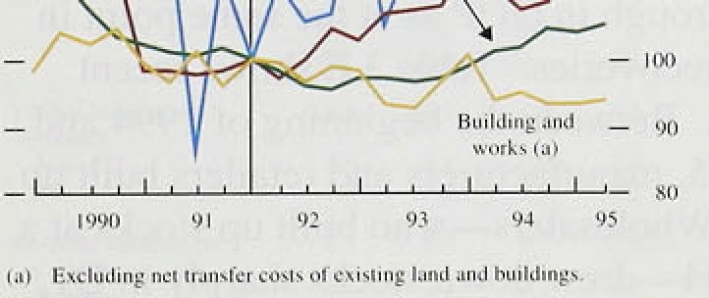

**Chart 3.5**

**Maniilacturiii**8 **'investment over the cycle**











T0tal /investment rose! by about I '/:*/e in the second qu5rter. Overal.I investment, excluding co.mmercial and residefitiil coriâtrulction, lcontinued its g•radual recovei‘y.

.Chart 3.4 shows that, st.rice the trough I R OUtF> In 1992 Q1,.investment in buildi.ng and works has fallen,

.whereas the i’est of investment has risen. At the same

.point. in the previous recovery, investment .in building afid works had increased. The box on page 22 reviews recent developments .in the construction industry; i1 cofic1u‹iés that there is still spare capacity ‹ind th‹it .i l!arge risé in buildirig investment is unlikely.

As Chart 3.5 shows, manufacturing investment, which

.accounted for about a tenth of total investment last year. rose sharply over the !past year or sO. By the second quarter of 1995, ntanufacturing plunt and rrincliinery investment had risen by 10% since the trough in GDP: ovér the .same.period in the previous recovery, it was

in



non-manufsctur:i:rig bus:iness i!nvestinent has been

.yr.eaker: ’The strength of riianufacturina investincnt is

:not surprising.. :Manufacturing outpul grew strougly last year„boosted by strong overseas demand. and capacity constraihts—thou.gh uncommon became more w.idespread. B/ecause (here are !ags. between. changes in ’output and investiñerit,!inanufactur.ers are prob‹ib1y still

.adjusting to:their desired capital..stock in. the lighl of higher output. :The CBJ"s /Octob.er Survey reported a t’all in manufacturifigi investrñéiit i.fi.tefiiions..in plant and machinery, though the balancle was.st1.11 positive. The









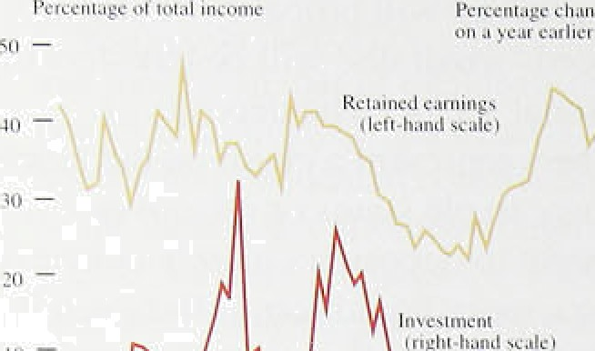L”I :›‹-t ñ.7



non-manufacturing sector faced fewer pressures to increase investment.

Company profits rose in the second quarter, but less quickly than last year. Between the second half of 1994 and the first half of 1995, they were roughly unchanged. Industrial and commercial companies’ retained earnings, as a share of their total income, started rising in 1991, and in 1995 Q2 returned to 50%—around their average since 1960. Chart 3.6 shows for businesses that, over the past l5 years. changes in retained earnings often preceded changes in investment growth, In the past few years, businesses used increased profits to repair their balance sheets but, with that process more or less complete, they may now increase investment (and pursue mergers and acquisitions).



During 1994, stockbuilding—excluding the alignment adjustment—was equivalent to about '/i% of GDP a quarter. In the first quarter of 1995 it fell, but in Q2 stocks rose by about ’/•% of GDP. By the second

quarter, stocks had contributed about the same amount to



* , " ;°0 , growth since the trough in GDP as at the same point in

›;{ ,„ the previous two recoveries. Table 3.E shows recent

changes to stocks. Between the beginning of 1994 and the middle of 1995, manufacturers and retailers built up stocks the most. Wholesalers—who built up stocks at a slower rate in 1994—drew down stocks sharply in Ql, but then rebuilt them in Q2.

The August *Report* outlined the risk to output if firms

**ht‹›ck-‹›tit}›ut nti‹›'** "



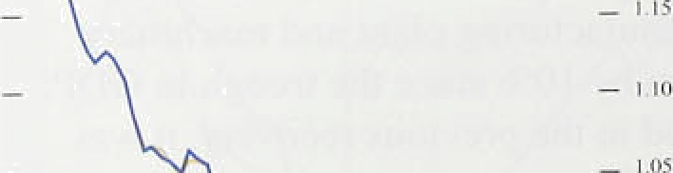



95



24

satisfied demand in the second half of the year by drawing on stocks rather than producing more. The second quarter’s rise in stockbuilding increased this risk, but the outlook depends on the extent to which the rise in stocks was planned.

Evidence from CBI surveys, the Bank’s Agents and stock-output ratios relative to long-run trends suggests that part of the build-up of finished manufactured and retail goods stocks was involuntary. Chart 3.7 shows how the aggregate stock-to-output ratio has fallen over a long period, partly because of the introduction of more efficient stock controls. Excluding the alignment adjustment, the stock-to-output ratio was roughly flat between mid-1994 and mid-1995; including the alignment adjustment, it rose. It seems unlikely that the ratio has reached a permanent trough; stocks, overall, are higher relative to output than in the United States, and the Bank’s Agents suggest that many firms are still



*Ji•iiir/iitl* r/rir/ s/‹/›/' /',’.

trying to econom ise .further on stocks. Nevertheless, inuch. of the .ri!se..in stocks o!’ raw materials this year was planned, in anticipation of increases to raw malerial prices.,

Output growth is sensitive to stock changes and there is a risk that changes to planned stocks will cut growth i!h the seconci half of the year, as .happened in the second.quarter in the United State.s. But the efi’ccts of such .a ‘stock cyc(e’ .are likely to be temporary. .as they

tu!rned out to..be in the Uni.ted States. A rundown of UK stocks may..explain part of the weakness ot’

 manufacturing .output during the summer. fi///›/rt i‹ ‹ /‹ .i rf‹'iiirir«/

.Iri the.second .quarter, general governme nt spending

(consumption and investment) t’elI by I.8°/ . Genei’al government .spending is volatile; last year it rose by

.2.80•: Last November ’s Budget pi ejected that, t›vei ihe three years I 995/06 to 1997/95, i’eal. govei’irnent spending., as measured by the ‘Control Total’—w’hich



:compi ises spending by central govcrnnicnt, local authorities and the financing o.f nationalised industi ies— wonid risk .by a total of 0.7%, .after i eat cumulative gro.iv.th. of over 7°/e iri the previ‹›us three years. Despite these,ti.ght spending lans, the publ ic sector borrowi.n* requirement (PSBR) ivas about I ’hi higher in the first six. months of the 1995/9.6 financial yciii‘ than i.n the sarfie period in the previous year. The Treasury’s Summer Forecast revised up its PSBR projection tot’ this

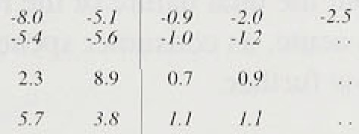

fi‘om k2l .5 billion to £23.6 bill ion, largely



.because of .flower projected tax receipts.

**3.2 Net external demand**

Tfie’current ascount defici.t rose belween the first.trrNl second quarters, to .l,.3:7e of **GDP** (see Table 3.F). In the

.fi!rst,quarter, the. whol’e of the inci‘ease in CiDP was accounted for by net exports, but in the second quarter net.exports fell..by the equivalent of ahorit thi’ee quartei s of a percentage !poi!nt of **GDP,** as expoi’t.s fell and imptr ts



.rose. . In.the third qu‹n’ter,..the isi.file trade deficit with non-EU countrie:s increased. Non-EU trade is just under half of. total. trade and normally provides a re‹isonable guide to the overall picture, if ‹allowance is made for differéntial .exchange .rate movements The CBI’s

 October Survey .recordéd, a faI.l in the balance of

mafiufâcturin :firrris reporting highei export order‘s over’ the:previous four.monflis. :Last year; ‹nanufacturing



 exports grew more strongly than!output—see Chart 3.8.



Manufacturing export volumes were roughly flat in the first half of this year. Has the dual nature of the recovery—characterised by strong exports and weak domestic demand—changed?

The slowdown in export growth in the first half of this year partly reflected the slowing of domestic demand growth in the United States. But growth there increased *in* the third quarter, as the effects of temporary destocking unwound. In Q3, the value of exports to North America rose by 4%. after a fall of 10a in Q2; total export volumes to non-EU countries also

recovered. In Germany, demand growth slowed down to around its trend rate over the summer. Last year, strong demand growth overseas, especially in the United States, contributed to buoyant UK export demand; the world economy is likely to provide less of a stimulus over the next year.

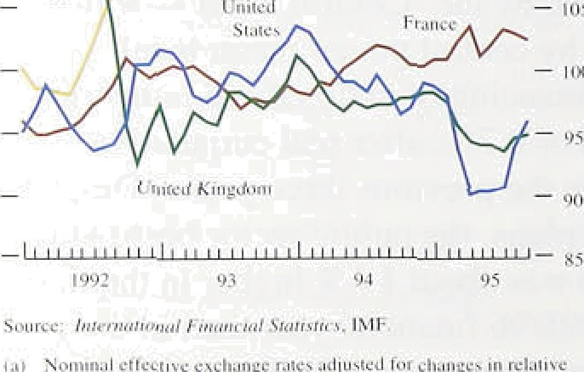The fall in the exchange rate in 1992, and subsequent improvements in price competitiveness, are still stimulating export growth. The fall in the real exchange

, rate this year (by about 3'/i% to September, the latest month for which comprehensive data are available), was much smaller than in 1992 (see Chart 3.9). Overall, net external demand may add a little to growth over the next few quarters, but the dual nature of the recovery is likely to become less acute, as consumer spending and investment grow further.

### 3 3 O t t

Output growth fell in the first three quarters of this year. Whole-economy and non-oil output rose by 0.5% in the third quarter and serviced output rose by 0.7% (the same as in the first two quarters of the year). Manufacturing output rose by 0.2&o in Q3.

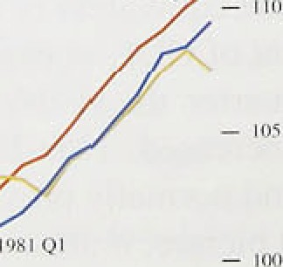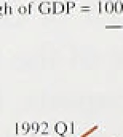

The previous *Report* highlighted the divergence between weak manufacturing and .strong service output growth, evident since about the fourth quarter of last year.

Services accounted for about two thirds **of GDP** in 1994. During this recovery. growth in services output has been a little stronger than in the two previous recoveries, as Chart 3.10 shows, though changes to the nature of the service sector during the past l5 years lessen the value of such comparisons. Most of the main service sectors grew at broadly stellar rates during the recovery, though transport and communications—which grew by 5.4% in the year to Q2, compared with 3.3&o for total service sector output—was an important exception. Much of



26





isrt3.11

:CiapamtJ **utillaadon in mnn; ufacturin**g







this growth was..generated by innovation in the teI'e1commtiications sector: The strength of transport sector output last year was.consistent. with the strength of export,:grnwth.

The slowdown in manufacturing output growth this year was also reflected in CBI and CIPs surveys, and reports irom the Bank's Agents. As growth slowed down. manufacturing capaeity utilisation stopped rising. The October **CBI** Survey.reported that manufacturing capacity utilisation was virtually unchanged over the previous four months, after a fall in the previous survey.

!Chart.3. 11.,shows that uti.lisation was still high by historical standards, and the Bank’s Agents reported capaei!ty pressures at some expon-orientated

.manufacturing firms. Overall though, firms faced with high demand pressures are able to use labour and capital more flexibly than in the past, for example by putting on

.extra shifts, and using contract and part-time staff.

### 3 4 S a

In!the second and third quarters, GDP grew at around its long-run average rate. It is still more likely than not that economic growth will increase over the next two years. narrowing the remaining output gap and reducing downward pressure on inflation. But the downside risks to output, especially in the short run, have increased since the previous *Report:* stocks were built up further fh Q2, increasing the risk of a temporary destocking cycle; the housing market conñnued to be weak; and net exports fell.





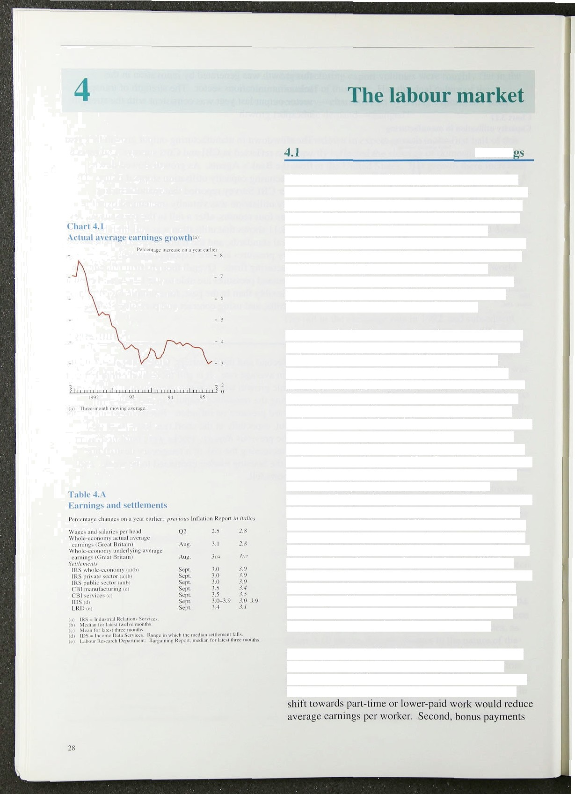

**Earnin**

Underlying annual nominal earnings growth has been remarkably stable at around 3‘/ % to 4&o for most of the past 18 months. But it fell unexpectedly from 3’/2&o in May to 3’/•% in July and remained at 3'/‹% in August. Underlying earflings in the service sector were particularly subdued. rising by only 2'/1% in the year to August; underlying manufacturing earnings increased by 4’/:%. Actual annual earnings growth, on a

three-month moving average basis, declined steadily from 3.9% last December to 3.0&r in July, but then increased to 3.1% in August (see Chart 4.1).

The recent decline in nominal earnings growth has not been driven by lower pay settlements (see Table 4.A). Industrial Relations Services **(IRS),** for example, reported that the median wage settlement across all industries was 3.0& in the twelve months to the end of September, unchanged from the twelve months to the end of June. And in the three months to September, settlements were slightly higher than in the three months to June. So earnings growth has fallen as a result of lower growth in the components of earnings other than basic pay. According to the New Earnings Survey, basic pay constitutes only 75% of gross pay: overtime pay accounts for 6% and bonuses 4%, with the rest accounted for by shift payments and grading increments. The gap between annual average earnings growth and settlements—called 'wage drift’—is normally positive, and averaged 1.7 percentage points between May 1984 and August 1995. But it has virtually disappeared since the beginning of the year. In particular, the **CBI** Pay Databank—which splits settlements by sector—suggests that wage drift in the manufacturing sector has fallen over the past 18 months but remained positive, while wage drfft in the service sector has fallen even more sharply and was negative in the second quarter.

The fact that the decline in average earnings growth in the service sector can be accounted for entirely by negative wage drift may mean the decline is temporary. Wage drift can be negative for three reasons. First, a



may increase more ,slowly than settlements. Chart 4.2.



earnings in financial



:interrne1‹iiation i.ndustries—such as banki.rig and

' “ ' !' "i! insurance. It suggests that large bon use.s wei e paid ou1

,„ . .in.both .February and March 1994, but in 1. 995 payments were made only i.n March. In total. bonus payiiients in

- '* fi.nancial intermediation industries were around 2fJ"/r tc› 30% lower i.n 1995 than in 1994. Third, there rnay be a decli.ne in the pt oportion of fivertitne paymenls.

*° W.hichever was the reason for’ the. recent episodc of n’egati.ve wage dri.ft, faster increases in bonuses, or’.a period of stability in part-,time work or overtinic, could

i increase wage drift significantly.

 .In:.the .past, wage drift has not remained negati u l’oi

.long.: Chart 4..3 shows when wap•e di’ift in the whole economy previously became nep•ative in 1993 Q4. it quickly rebounded by over‘ one and a half percentage points.. At that time, settleiiients were on a dowiiiv‹ird trend, so



Other periods of neizative wage drift have encled w•iih an even sharper recovery. If a sharp rebound were to occur againsl a backdrop .of flat settlements, aveixige earnings



growth would also rise.



**(:.Cir.eat** Britain).':



’ Eslim rim 8t.fire:tlme:'out. . ‘ Annu bi Curren i

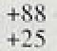

+fI4'

**Labour.:£'orci'Sur.vej'”'**



Sun(crier L99.4:iO';nutuiuu'94-

**Aat’mlI†994tOAMntL94%5,**





Employment.has .increased strongly th.i.s ) ear. according to d.ala released since the August *Rej orl.* The Labottr Force Survey recorded a. 107,000 increase in employment between. the spring and the summer.

: compared with an increase of 25,000 o\her the pi’evious 'quarter, The. CSO’s.employer-based surve)• showed a smaller 1.4,000 i.ncreiise in the number of jobs between March.and June:‹ ' In the past, lhe two series have

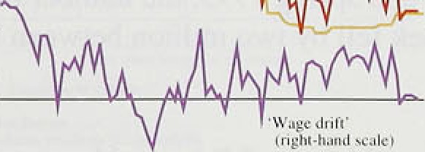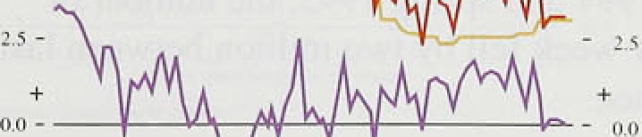

fiiver8 nificantly„ :but substantial i‘evisions ter the estimate of the workforce in employment .since 'Decerriber 1992 have reduced st›me of the discrepancies



The CSO estimates thai the workforce in. einployinent has risen by 374,000 since the ti‘ouqh .in employment. compared with ,the LFS estiinatc of **564,.000.**





Trends Survey found::that,. for the first time since July  manufactn:ring fi:rms! had:taken ofi staff over the

.+26



: Dec<rnb<r I ys3 ‹a:March 94 Mcrcl› l9'?4 to June 94..

+ 14

preivfous. foui^months. , A balance o.f:3?r re they had!hi.red

orted that

'+374



in "I.u!ly expecti!ng to, shed staff. The Chartered Insti.tute





’I’:i1ile 4.t’

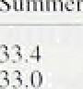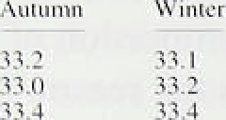\a v t.qiv h‹iiit s u t›i ked i I, rriit E ritain 1



of Purchasing and Supply—which also covers manufacturing firms—suggested that there was no increase in labour demand in October. According to its latest monthly survey, employment had increased for 20 consecutive months, but there were some net job losses in October. But the latest Manpower Survey—which covers all m.min sectors of the economy—was positive. It showed that more employers were expecting to take on staff than to see staff levels fall over the following four months; retailing was the most optimistic sector, and banking and insurance the most depressed.



t.’It th t 4.4

l'. In{›1t›i merit u nil **outpul** gr‹iss't h



' ""'

* *‘ A wore accurate measure of labour demand is the total number of hours worked in the economy. According to the LFS, seasonally adjusted total hours worked per week were I.79r higher in the summer of 1995 than in the same period a year earlier: manufacturing hours were up 2.One over the year, while service sector hours rose l.59n. This sectoral breakdown contrasts with the employment data, which showed that the number of

, service sector’jobs rose by 329,000 (I.9%), compared with just a 54,000 ( l.l%) increase in the number of jobs in manufacturing industry. But there were signs that

' labour demand weakened in the summer, when both full and part-time employment were rising strongly.

Whereas total hours worked increased in each quarter between spring 1994 and spring 1995, the number of hours worked per week fell by two million between last spring and summer.



„ • There are two ways in which the fall in total hours

worked over the summer could have accompanied a rise in both fu)l and part-time employment. First, overtime working could have been cut back severely. Second, the average working week could have been shortened, by more people working fewer hours—resulting, for example, from a temporary surge in summer jobs.

““”"' ” ' Indeed, seasonally adjusted average weekly hours fell

from 33.5 hours a week to 33.3 between the spring and summer of 1995 (see Table 4.C).

There is some evidence that employment has become more sensitive to changes in demand during the most recent economic cycle. In particular, the size of the response of employment to output appears to have risen (Chan 4.4). This may be a result of the labour market reforms in the 1980s, which made it easier and cheaper for firms to hire and fire workers. Chart 4.5 shows that, although employment rose slightly earlier in the current cycle, it increased much less quickly over the past year than at a similar stage in the previous upturn.





Unem to ment

. I•tvtl ohmcmp1oYment (the'\frauds)., .



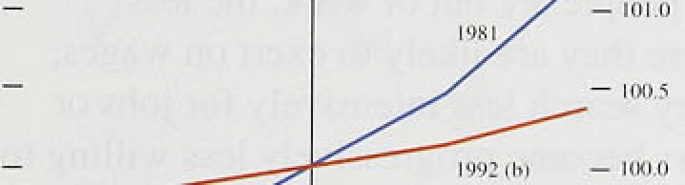



.35—



Accorciing to the latest LFS, uneinyluyment w .s down between. June rind August, after rising by

28,000 fn the previous three months. Claimant unemployment started to fall faster, after slowing for’ the

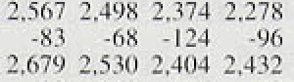

2.23!l-2'.203



!.first six months of 1955 and stabilisin* in July. The

›. clai:rñant count.fel.l by 2.1, .100 in A:ugust .and a further in (see Table 4.D for the quarterly



clhanges)."' The average three-monthly fall in lhe claimant count is still lower than at the end tif 1994: it

'00 in the three months to September. compared with 47,900 in the three months to December.



Unerr ployment started to fall much earlier in the cui‘rcn1 recovery than in previous cycles. It has also fallen

much further. Since the most recent ti ough in GDP, elaimafit unemployment has decl ined by a total of 350,0,00. This compares with a ri.ir of 952.000 in the first three. afid a half years of the recovery in the e‹irly 1,980s.

'The.supply .o’f.labour i.ncreased between June and AuguSt. .Indéed, the population of working a*e i’ose by

!around1!25,.000 in the quarter’ to spring 199a and b a further 25.000 in the following quai ter. S i rice the star t of the’recovery, it his gi’own. by over 225,000, however.

.compared with. a rise of approximately 700,0(1O dui i rig the first three and a quarter years of the eai‘ly I 9SOs recovery (see Chart 4.6). The change in the population

:of ivorki.ng age alofie amounts to around a third of the difference' in the level of unemploymen t between the two recoveries, .although there is no reason to suppose t1i:i1

!demog.rapli.ic factors should affect significantly the long-ru:n equilibrium. rate! of unemployment.

Labour supply in the.cui’rent recovei’!y has also been

.reduced by ,a rise'in the number of people .not actively seeki:ng work partly ñs a result of young people entering higher education, Despite falli.i3.g between last winter and.this summer. the number of people of’ work!irig .age. not-aetively .s'eeking work i’ose by 325,000 in. lire: first three years of the!recpvery (see Chart 4.7). lii the.early 1980s. recovery, the LFS sug.gests thal the

n.urr ber of:people of w.o!king age not.activ.ely seeking work rose even more:strongly, .



lnll‹iii‹in Rcpt›ri: November I •795

The number of people who would *potentially* seek work as labour market conditions improve is important for future wage pressure. The Employment Department expects the population of working age to increase by

250.000 during 1996 and 1997. Although this is more than in 1994 and 1995. it is still much less than the 370,000 increase in the pool of labour between 1984 and 1986. However, the fact that inactivity has yet to fall significantly could mean that the labour force could expand quite rapidly with little pressure on wages—if, for example, people were easily tempted out of further education and into jobs.

### 4 Mea es f labo ket t htnes

The effective exec.+s supply of labour depends on the composition of unemployment as well as on its overall level. The longer people are out of work. the less downward pressure they are likely to exert on wages, either because they search less intensively for jobs or because employers become progressively less willing to hire people without recent work experience. As a result, the number of short-term unemployed may be a more important determinant of wage pressure than the overall number of people out of work. The recent declined in unemployment have been broadly based. The number of people out of work for less than 52 weeks fell from

1.95 million at its peak to 1.49 million in September— the same proportionate amount as the fall in total unemployment.

C he rt 4.8

ltali‹i i›f* ii urns pli›j ment ft}' **iteration**





Vacancies are another useful measure of labour market tightness. As slack in the labour market lessens, there should be more vacancies per unemployed worker.

Vacancies reported to Jobcentres rose by 10,300 in September, after increasing by 2,600 in August. They

” were flat in each of the previous two months. Although vacancies are not rising as fast as they did in 1994, Chart 4.8 shows a sharp fall in the ratio of short-term

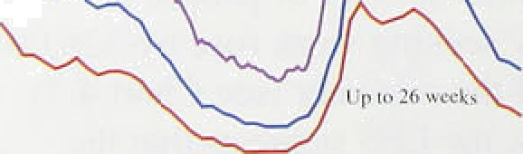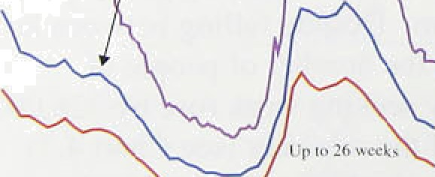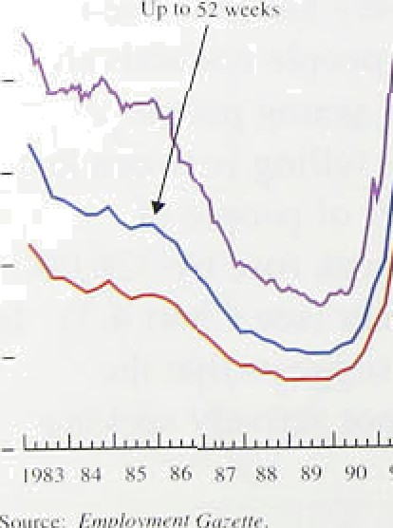

"'

, unemployed to advertised job vacancies to just under 6% in July—around its level at the beginning of 1987.

- I 5

So far, there has been little evidence of skill shortages.

” The October CBI Quarterly Trends Survey reported that a balance of l0&o of firms thought a shortage of skilled labour was likely to constmin output over the following

„ four months—a figure which has been practically unchanged in each of the past five quarterly surveys. This is not surprising. During the 1980s recovery, skill shortages started to pick up rapidly only in 1987—six years into the upturn. It is possible therefore that skill

32



shortages will. soo.n .become a much greater constraint on ou:tpu:t.

##### 6 E at i h v o r f w

There are two main puzzles in recent wage behaviour. The first i.â that.real wages have been much more subdtied over the current cycle than expected, g ives that unemployment i› mum.rig and in September was around its level in the middle of 1988. Nominal wages i!ncreased by 3.1 % in the year to August, less than the 3.6,9r."increase in retail prices over the same peri‹›d. In other ivords, real wages fel.l over the year to August.



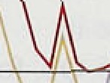The puzzle is intensified when taxes are taken into ’account. Increases. in taxes over the past tw‹› yeiirs would,. other things being• equal. have tended to push up earfiin.gs for any given unemployment i’ate. The Tax and Price Index (TPI.J measures the increase in gross i.ncoire requi.red for taxpayers to iiiaintain their spendin.g power‘. taki.rig a'ccount of direct taxes as well as prices.

.Chart 4.9 shows that the TPI has been increasing faster than the GDP deflator since the beginning of 1994. This increase in the wedge’ between lhe consuinpti.on wage and the product wage would have cxerted upward pressure on wages if employees attemr ted to recoup



some of their lost purchasing power in higher real

wages. Chart 4.9 also decomposes the wedye intti tei‘ins of trade effects. and changes in the tax and price index relafi!ve to RPIY. Both have tended to reduce the consuinption wage relative to the product wage since the ’beginfiing of 1994. Chan 4.10 compares the consumption wage. in. the current upturn wilh its path in



 the‘pfevious recovery.

The second puzzle is the continued divcrg•ence between ’!the?grovith of noiiiinal manufacturing and service sector earnings: Underlying service sector’ annual earnings have i!ricreased particularly slowly .during the recovei’y.

°*° as a! result .of falling wage .dri.ft in the service sector,

» • while underlying manutacturing annual earninp•s have

„„ risen tnore .strongly. Yet service sectoi employment increased from I 7.2 .million to 1 8.0 in.ill.ion between



.spring l'992 and summer 1995—a period during which the number of jobs in manufacturing industry fell from 5:0 mil.lion to 4-9 riil!.ion..

” **There** are t1iree.possible explanations for the real wages ” .puzzle. First; *expected* real wages may have. started to

increase, offset by a.shader:fall in. .i.n.Station expectations.. This does not seerri to have been the. case. Because i.riflatioii. expec1taf'iohs are volati!le. Chart 4.1 l

In lJatiiili R.eP'!* No member I ')95

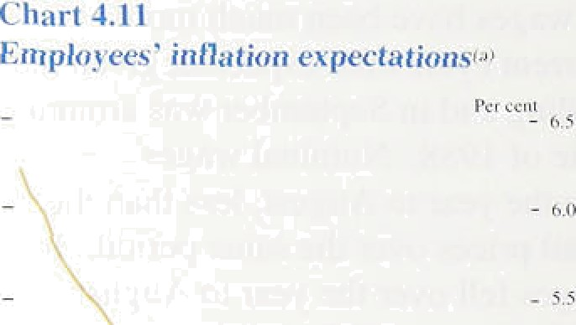takes a six-month moving average of the inflation rate expected in twelve months’ time by employees surveyed by Gallup. On this basis, expectations fell between January and September, but not sufficiently to account for the behaviour of nominal wages. The Gallup Survey also suggested that workers expected a *cut* in real wages over the coming year. Prices were expected to rise by 4.5%, while wages were expected to increase only 3.1%.

Second, there could be a time lag between a fall in unemployment and an increase in real wages, so real wages may be about to increase sharply—with a consequent acceleration of nominal earnings. In the past, there have been episodes in which nominal wage growth increased suddenly with little change in unemployment. Between 1984 Q2 and 1985 Q2, for example, wage inflation increased by about four percentage points at a time when unemployment was actually *increasing* (Chart 4.12). The course of settlements over’ i 996 will become clearer in January, a month in which a significant proportion of all annual settlements is implemented. Higher settlements, accompanied by a rebound in wage drift, would be consistent with this explanation.



Third, average *h,ourI y* wages—more relevant when measuring inflationary pressure than total earnings— may be increasing more quickly than suggested by the average annual earnings figures. A shift towards

part-time work would both reduce weekly earnings per worker and—if part-timers earn less per hour than

full-time workers because, for example, they have less bargaining power—would depress the average hourly wage. The first of these effects can be investigated using LFS hourly earnings data for full-time workers. These show that nominal hourly earnings increased by 3.5% in the year to the spring, much the same as the headline earnings data suggested. So the hourly real wage of full-time workers had not at that time started to increase.



_ , More remarkable is the contrasting behaviour of hourly ''' ' ” earnings of full-time workers in manufacturing and

"“" '"”” services. Nominal hourly earnings for full-time service sector workers rose by 4.69a in the year to the spring. In manufacturing, however, nominal hourly earnings fell by 1.0% in the year to the spring. This is consistent, however, with data for total hours worked in the year to the spring—they increased by 2.4% in services, compared with 2.0&o in manufacturing—and provides a partial resolution of the second puzzle.

14

:'.None.o.f the .abo:ve possibilities is.abIe to explain the

,subd/u’ed behavio’ur of real wages so .far in the recovery.

.lii:particu1ar; .the .decl.i.ne in. nom.inal hourly wages in rnanufae?uriiig over the past year suggest.s sharp cuts in real wages. Ser vice sector hourly nominal pay rose ft›r full-time workers but since .services iâ the sector which saw the greatest shift towards part-time woi‘k, earnings in that.sector are..most l.ikely to. be exaggerated by the full-time..hourly pay data. Either’ real wages arc about to pick cup, or unemployment remnins xignificantly above

i!ts natu.r3.I rate..and traditional indicators of labour war ke1 tightness are underestimating the degi‘ee o1’ .slack i ii the

,economy.

’Fablé'4:E.

**Unit-ivage costs and** their **coriipon'entsl**

##### 4 P o cti n t a t

The gro,wth o.I productivity per head has been slow in • since .1994 Q2=-it increased by ] .8% in the year to 1995 Q2. Estimates of pt‘oductivity growth to the



U•|tu 'i• .manu.facturi.ng sector show an even more marked

.decline: .productivity increased by I.77c in the year to

, „ „, 1955 Q2, down trom 5.5°/o in 1994 Q4. The t’all in

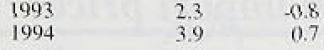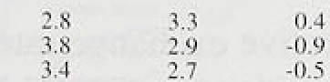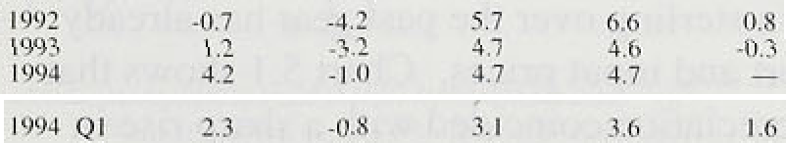

{*. ;' ., productivity growth is largely a cyclical phenomenon.

Mi:rroring. this.fall, unit wage costs have picked up

.sharply. In the year to 1S95 Q2, whti[e-economy unit wage.costs increased by 0.7 And inanufactut ing unii

### 4.8 Summary

i ! .; ,i‹!’* Einployriient inéreased between the spring and the iil * summer and LFS unemployment resumed its

downward trend—largely as a i esult of more people orkirig .part -time jobs. But there was *Ro* sign of an

increase. in the. demand for labour o.ver the sumrrler when

.measured by'total hours worked. There has been little

.reign of 3ny infire35e i.n real weekl.y or real hourly earn!i!ngs..since the .start of,the: upturn. so unemployment probably remains above its natural rate.

 **Pricing behaviour**

Since the August *Rep‹›rt,* producer input prices have continued to rise. though at a slower rate than earlier in the year. The twelve-month change in manufacturing unit wage costs rose in the summer. And producer output prices continued to rise much faster than retail prices, suggesting that retailers’ profit margins have

been squeezed. The exchange rate has risen a little since the previous *Re ›cmz,* and its effective index is about the same as it was in May. when second-round effects from the depreciation in early 1995 were identified as a risk to achieving the inflation target. The cost and pricing developments assessed in this section should affect inflation only in the short run, unless they reflect monetary developments or affect expectations and become embedded in future wage and price setting.

#### 5er1a

The e han

e d o es

C‘hiii t â.l



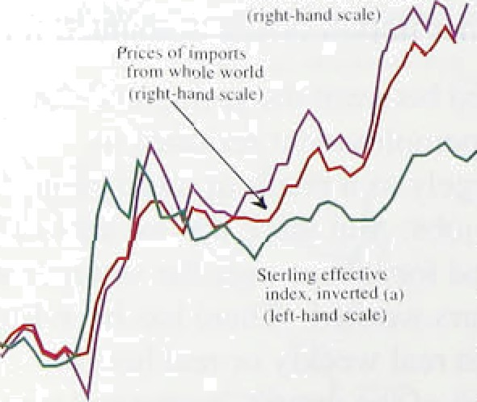

— 110

Sterling’s effective exchange rate index rose from 83.4 to 84.3 between the August and November *Reports,* but ended the period at about the *same* level as in May (see Chart 5.1). The direct (or first-round) effect of the depreciation in sterling over the past year has already affected import and input prices. Chart 5.1 shows that the recent depreciation coincided with a sharp rise in import prices and that, in contrast to 1992 (when sterling’s membership of the ERM was suspended). import prices rose by more than the fall in the exchange rate. This was probably because the rise in import prices reflected not only the fall in sterling in the first quarter of this year but also the strength of imported commodity prices last year.

In the short run. the extent to which import price rises are passed through to final prices depends, among other things, on the extent to which prices are fixed in

long-term contracts and whether the rises are expected to persist. Over the long term, the response of final prices will depend on the reasons for the rise in impon prices and the stance of monetary policy. In the short run, however. price increases due solely to higher import and input prices might be misinterpreted as signs of higher domestically generated inflation. But, as yet, the potential second-round **effects** from the fall in the exchange rate, such as a rise in earnings growth, have not occurred.



Commodity rr ices, as measured by the Bank’s index,

.féll in the thi:rd quarter and were no higher than in the middle of last year,..as il.lustrated in Chai’t .5.2, which also shows that .a crude pi oxy for impoi ted commodity *prices* has risen .over the past year’. The divergence betwecn these two indices i‘efIects di.fferent c‹iverage and weighting: the Bank’s index i.s demand-weighted and

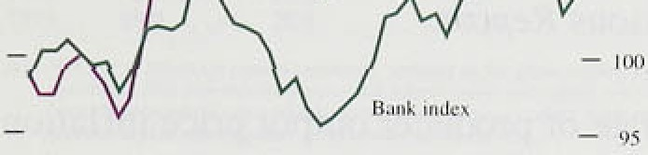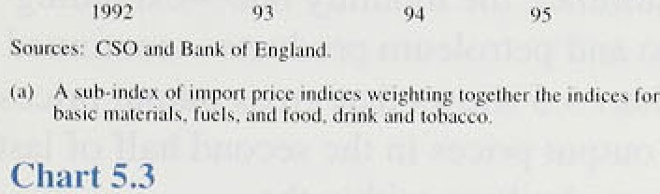

" co,vers domestic. commodities too.' ' Growth in woi Id demand has slowed ñy more than expected thi.s year and this .has reduced the demand pressure on industrial raw rriaterial prices. lii .October, the IMF’s *W‹›i lxl Ecoiu›mi‹’ 0!utlâok* projected a risc of 2.5°Z‹ in GDP in the industrial countries in 1995; six months earlier’, it had projected 3%. Last year, in response to stronger-than-expected demand pressui es, metal and non-food agricultural prices in the Bank’s commodity .index i‘ose by 21°J and 17% respectively. In the first nine months ot’ this year’.

they fell, while food prices—which account t’or about a

 th.i.rd of the .Bank index—were roughly unchanged.

### 5. 3 I u a id t ut r

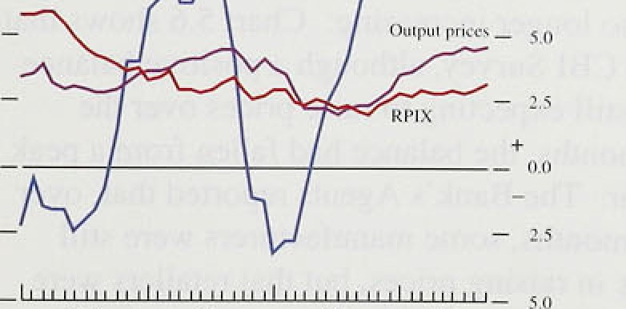

Producer input. prices.. like commodity prices, decelei:ated in the three months .to Septembe, r

Chart 5.3 sho:ws.ho.w the twelve-month rate fel I fi’orn its rate in. January., But, in ten out of the twelve months It› August, the initiall.y reported rise in input prices was later reviseci up. Higher import prices accounted for afiout thre'e quarters of the rise i.n producer input pi’ices in.the year to September, reflecti.rig the strength .of some fipmrnodity and imported semi-manufactured goods’ prices, su‹ih as chemicals. .metals and other i.trported inputs..

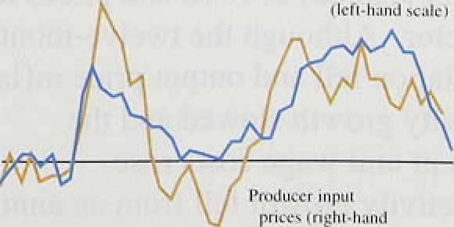

• .• ...0› — ,

- i‹,:

Wiiat are the prospects for input .prices? The effective exchangg.,rate has i.nci eased a little since the previous

*Repor.t; so* import pi ice pressures :may ease.

Commodity

prices .féll in .Q3, suggesting that the annual r‹tte of i.nput

price.rises nil.l probably fal.l further.

This is supported

.!by thee CIPS Survey (!which measure.s price pressu.res

.with:n !he roaniifacturing sector.,:and is thei’efore probably more closely related to input prices than output prices).’ Ch3rt 5:4:con.firms this weakening of input price pressures !a:nd shows.that .in October thel **CIPS** index

**:feli** further.,







LIII: i“l 6.

Ratic **‹›f grnss l‹› net ‹›titput prices**

Over the long term, producer input prices are not well correlated with output prices. Materials and fuels

""' - n (including semi-manufactured imports) account for only about a quarter of producers’ variable costs, according to

- i input-output data, whereas labour costs amount to around a half. So it is probably more important to look

_ „, at output prices and unit wage costs as indicators of potential short-run inflationary pressure—and there is little evidence that pressures from these sources have eased since the previous *Report.*

.›' • ›‹ •‹

L/ hai t 5.f›

**Pr‹iilticcr** mid **put ›rice inflation and Clll**

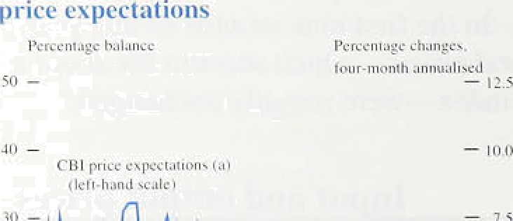

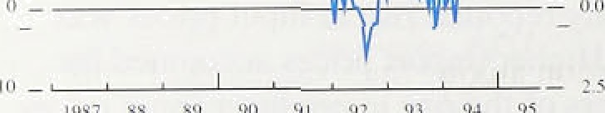



Table 3..S

**Rates of’ change ‹›t’ inanul’acturers’ costs**





**C’iysts**



0.4

lin p'›ris of I tni shell



The twelve-month rate of producer output price inflation rose from around 2% in mid-1994 to 4.5% in September 1995. During the summer, the monthly date—excluding food, drink, tobacco and petroleum product ontinued at around 0.49c. Chart 5.5 shows that gross output prices rose relative to net output prices in the second half of last year, as price pressures built up within the

manufacturing sector.( ' I In the first nine months of this

year, gross prices stopped rising relative to net. but there may still be some price rises to work through.

Survey data indicate that producer output price

pressures are no longer increasing: Chart 5.6 shows that, in the October CBI Survey, although a positive balance of firms were still expecting to raise prices over the coming four months, the balance had fallen from a peak earlier this year, The Bank’s Agents reported that, over the past three months, some manufacturers were still having success in raising prices, but that retailers were still having difficulty in passing on non-food price increases to price-sensitive consumers. By contrast,

food retailers were having more success in passing on price rises, consistent with the evidence reported in Section 1.

Table 5.A shows recent changes in costs and prices in the manufacturing sector. Although the twel ve-rrionth rate of input price inflation fell and output price inflation levelled off, productivity growth slowed and the

twelve-month growth in unit wage costs rose. Manufacturing productivity growth fell from an annual rate of more than 6% in the second half of last year to less than 2&o in Q2. Between 1992 and 1994, unit wage cost pressures were very subdued; this helped to offset

„ u„„ ,„„„„ „ „, , , ‹.2 ‹.i some of the squeeze on profitability frorri higher raw

, , „ , , „„ ., , material prices last year. In contrast to 1993 and **1994,**

* •• • • all of the main elements of manufacturers’ costs were " “"’ ' “ increasing in the year to **1995** Q2.

( I) Gross oulput prices include the prices paid for goods «xchanged within

Lhe manufaciufing sector: net output prices do not.





As Table 1..B shows, the profi.tabiI.ity of non North Sea ICCs rose last years—to its .highest rate since *1.* 959. In tire first half of I 9S5,..ICCs’ profits were roughly uricha.rig.ed. so. profitabi.lity probably stopped rising.' ' '

Equity, prices react to. changes in expected future dividends an‹J the inter est rate at which they are

.discounted. Changes in.:.the discount rate at e likely to affecrall :eq.nity prices similarly, so changes in sectoral

.share infiicesl relative to the total mai‘ket index i effect news afiout future profits of the sector. Las1 year, the eng:neering sector of the FT-SE All-3liare indcx ro.se relative to the total-li.nked pi‘obably to the strength of

.engineering exports .and exr ected future dividend payments. By contrast, the i.ndex fOt the consumer

.goods sector was. roughly unclt‹inged relative to the market. In the fi!rst nineanonths of this year. both

.sectors. increased relative. tt› the market. Proiitabilily hirs also ‹ii.verged wi.tfiin the retailing sector, with larger fi.rms generally doing better’ than small retailers. Small retai.lers’ sales vnlues tel.l in the year to J tily. contrasting with a rise of 7% for’ large retailer’s.

Those sectors where profits are being squeezed most are likely to experience upward pressure on price.s, as the weakest fi.i ms leave the sector. reducing the Extent of competition. In some c:its. remaining firms may be able ;o.push, down unit costs as well, depending on the degreetof competition. among their suppliers. Firms will

.be teinptéd to enter the most profitable sectors. putttn downward pressure on their prices but also. in some cases, bidd1n% u.p unit costs..

#### .5 5 A ste e r es

The previous *Rrporr* outl.ined some of the an.nounced changes .in utility .prices \rhich wi.h affect RPIX inflation ovei the riex.t tw0. ye;ars. Since the August *Rr port,* electricity. companies have announced that they will ‘offei’ custoriers.a £50 payment leach. when the National

!Grid is sdld. The:payments wit.h.be made during• the l’ii‘st hxlf of‘ 1 99fi. ’lf they ate.ti’.cated as a price cut by the **CSO.** the arithmetic effe’ct .on, quarterly projections of

a:nnual **RPIX** inflation—assuming fio. secrind-round effects—will be to cut it by arouiid”tlireé..ijuarters of a perc'entage point on Average:in the first .hel.f’ ot’ 1996. and



lnt1iition_ Report: November 1995 _

to increase itlby the:same:amount.:in. the fir4t half/of 1997; as its effect âraps:out.of the twelve-month. comparison. No allowance: has .bees made.fork.hits. i!n the projections shown in Section 6..



Since the previousi *Report,* th*e* rate .of incre se of iñput' prices has fal.len, though over the past year initial.rises. in: input prices have tended to. bé1 revised ap. Output price: rises have remained roughly constant, but,unit wage. costs have accelerated. Because wage eosts!!ha!ve such.a large weight in total variable c.osts, overall cost pressu'rds1 have probably increased since the August *Report.* .So domestic profit margins have probably been! squeezed:.



# 6.1 The economic news

The following salient facts emerge from the previous sections:

Inflation has edged up from June, whether

measured on a three or a twelve-month basis. RPIX inflation rose above 3% in September. This was faster than projected in the August *Report*

primarily because of higher seasonal food prices

(Section l).

Narrow and broad money growth stopped rising in September, but the monitoring range for MO (0&«—49p) was exceeded and the range for M4 (3%—9%) nearly so. The rapid expansion of credit. especially to the corporate sector, continued (Section 2).

Sterling’s effective exchange rate rose by I.I 9c in the three months to 3 November. Market interest rates tended to fall, as did expectations of rates in the near future (Section 2).

Nominal GDP is rising more slowly than the rate implied by trend real growth and inflation at the target level (Section 3).

Real GDP grew at around its long-run average rate in the second and third quarters, although manufacturing and the retail sector were weak, and the markets for housing and construction showed few signs of recovery. New information about the composition of demand in the second quarter revealed that domestic demand rose sharply after a large fall in the first. Stockbuilding was equivalent *ta* about three quarters of a percentage point of GDP, even more than in the first quarter (Section 3).

Export growth slackened in the first half of this year, largely because of lower domestic demand growth in the United States. The visible trade deficit with non-EU countries increased in the third quarter. Domestic demand overseas has been a little weaker than expected this year tsection 3).



Underlying at.erage earnings, growth:.(e1l.slightly between May.:and.August, alth;ough there.we.re some signs!of higher settlements’ln September. Wage drift in. the services'sector iii pârticular'has been exceptionally low or even negative (Section 4).

Employment increased in the summer, but the signs. are that total labour demand did not.

Unemployment has continued.to fall (Section 4).

Commodity primes fell .ion..the third gutter; and producer input prices slowed down more than did domestic output prices. But manufacturing productivity also decelerated, so.the profitability of domestic markets probably did not increase (Section 5).

### 6 2 B k s e te e t n

There has not been any major inflation surprise since the August Report. Betweem Junetand September, RPIX increased by just over 0.1 percentage.poltltS. more tlian projected in August. If food prices are excluded, inflation fell.

Industrial production was unchanged.between March and September, and manufacturing output fel!l..by ,0.3, Total GDP in the.third quarter is,estimated to.liave been

2.4&.h igher than a year earliex, but.services expande;i by 2.2% while the rest of the! eco.nomy (accounting for just over one third of output) grew by only 1.09o,

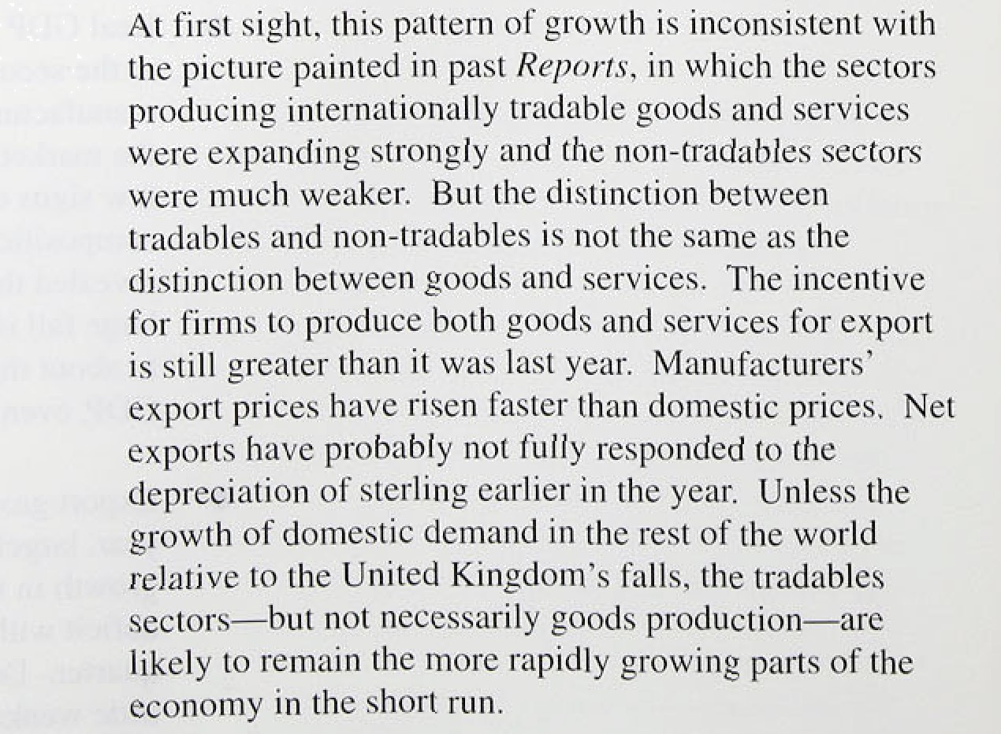

42

Thi's short-run.picture is complicated by the behaviour *of* stocks: .An. increase in stock-output ratios and the recent we akness, of manufacturing output suggest that some of tñe extensive stoekbuilding in the first half of this year was itixoluntary. Domestic demand—excluding stocks—may have increased sufficiently rapidly in the third quarter to counteract the effects of any attempted

,desiocking. But until the composition of demand in the

third quarter fs known, a continuing overhang pf unwanted stocks—and a future downward inventory

.correction—cannot be ruled out. If such a correction did

,occur, it would have only a small downward impact on inflation in the medium term, unless it triggered a slowdown in the underlying growth of domestic

##### .demand.

In.the long run, inflation is determined by monetary

.growth, but in.the short run the state of the business cycle. is also important. When output is below its

long-rim potential path, and unemployment is above its natural rate, there is downward pressure on in.flation relative to its expected rate. A rise in inflation expectations puts upward pressure on wage settlements and prices. If it were accommodated by monetary policy. actual inflation would also rise. So along a spectrum 1of shorter to longer-run influences on inflation, the key issues for the inflation outlook are:

*n* How will tfie components of demand evolve?

 Will earnings accelerate significantly?

Is the rapid growth of money and credit a temporary .phenomenon, reflecting changes in the ielation3hip between: desired holdings of money and nomina! income, :or is it a signal that nominal deman-d will accelerate?

First, it seems likely that consumers have now largely

.adjusted their desired consumption to the fiscal conso1i‹iation of the past three years. So consumption is

,exp.eeted from now on to grow somewiiat faster. at pqnd its long-run trend rate. Investment may be held ñack relative to past reco.veries.by low demand for new **eommereiâl ñuil‹iings** and works, and business **uonfi8ence** and!investment intentions **are** weaker than at the time of the’previous *Re!port.* Public spending growth



43

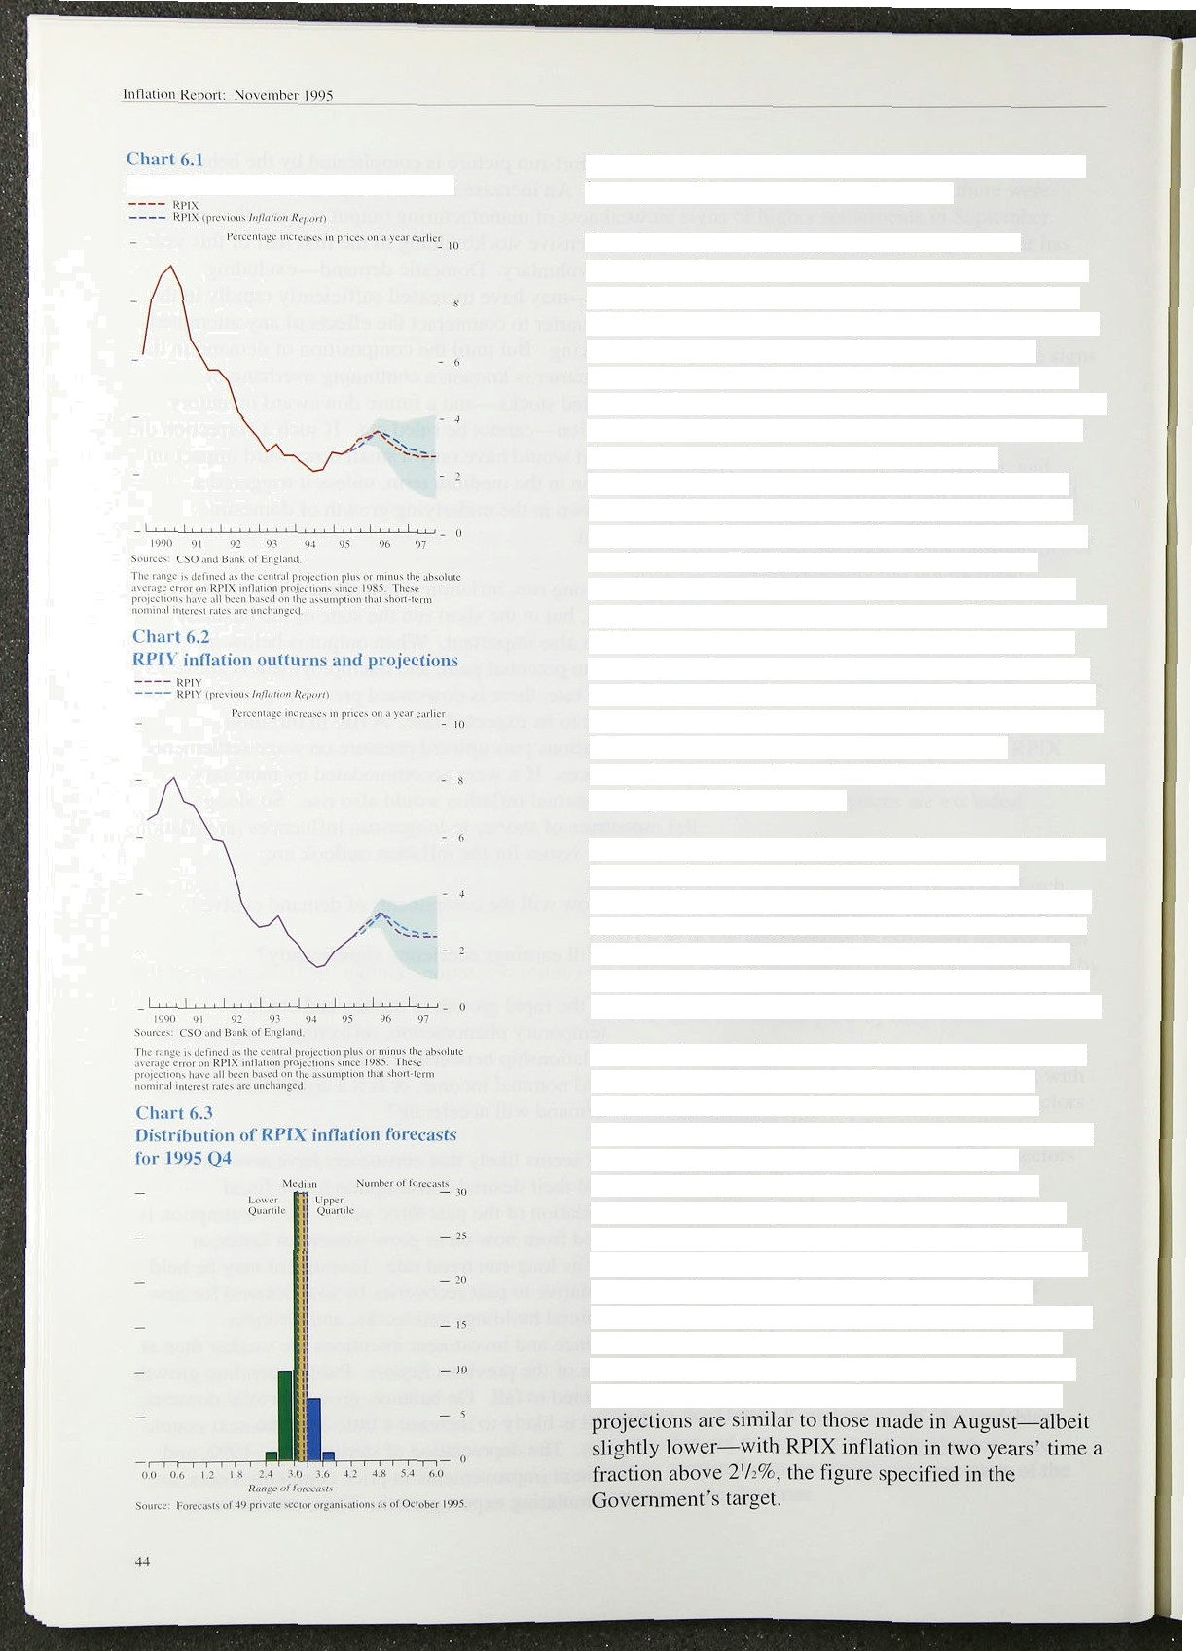

R PI X **inllatinn nutturiis and p•• i eclions**

clear risks on both sides of this central view, especially in respect of investment and net expons.

The second issue for the inflation outlook is the behaviour of earnings. Some rise in earnings growth is expected, and is incorporated in the central projection. Will this exceed the rate compatible with target inflation and falling unemployment? There are three main reasons why this might happen. Pirst, pay settlements

might pick up in response to adverse supply shocks, such as the increase in seasonal food prices. The price rises that such supply shocks bring about might be misinterpreted as a sign that underlying inflation had increased, thus pushing up wage bargainers inflation expectations. Second, wage drift might reappear in the service sector. The factors, such as an increase in

pan-time work, which have suppressed the usual drift cannot be relied upon to do so in future. Third, given the fall in unemployment, the growth of real earnings has been slower than expected. A return to the relationship seen in the past could be triggered by a few high-profile pay settlements. These risks have to be balanced against the possibility that the long-run natural rate of unemployment has fallen, increasing downward pressure on the growth of real wages.

The third issue—the rapid growth of money and credit— turns on whether there has been a change in the relationship between money and nominal demand. The central view—based on the discussion in Section 2—is that broad money growth will soon begin to fall back somewhat. If it does not, then nominal demand growth might accelerate leading to higher inflation in the future.

The Bank’s central projections for twelve-month **RPIX** and **RPIY** inflation two years ahead are shown in Charts 6.1 and 6.2. It is assumed that official UK interest rares remain unchanged over the next two years and that the exchange rate evolves according to uncovered interest parity from its level of 84.3 on

3 November. No adjustment has been made for next year’s electricity rebates, the treatment of which in the **RPI** has yet to be determined. The central projection is the Bank’s judgment about the single most likely outcome for inflation. Of course, a wide range of other outcomes is possible, but the Bank’s view is that the risks surrounding the centml projection are now more evenly balanced than earlier in the year. The central

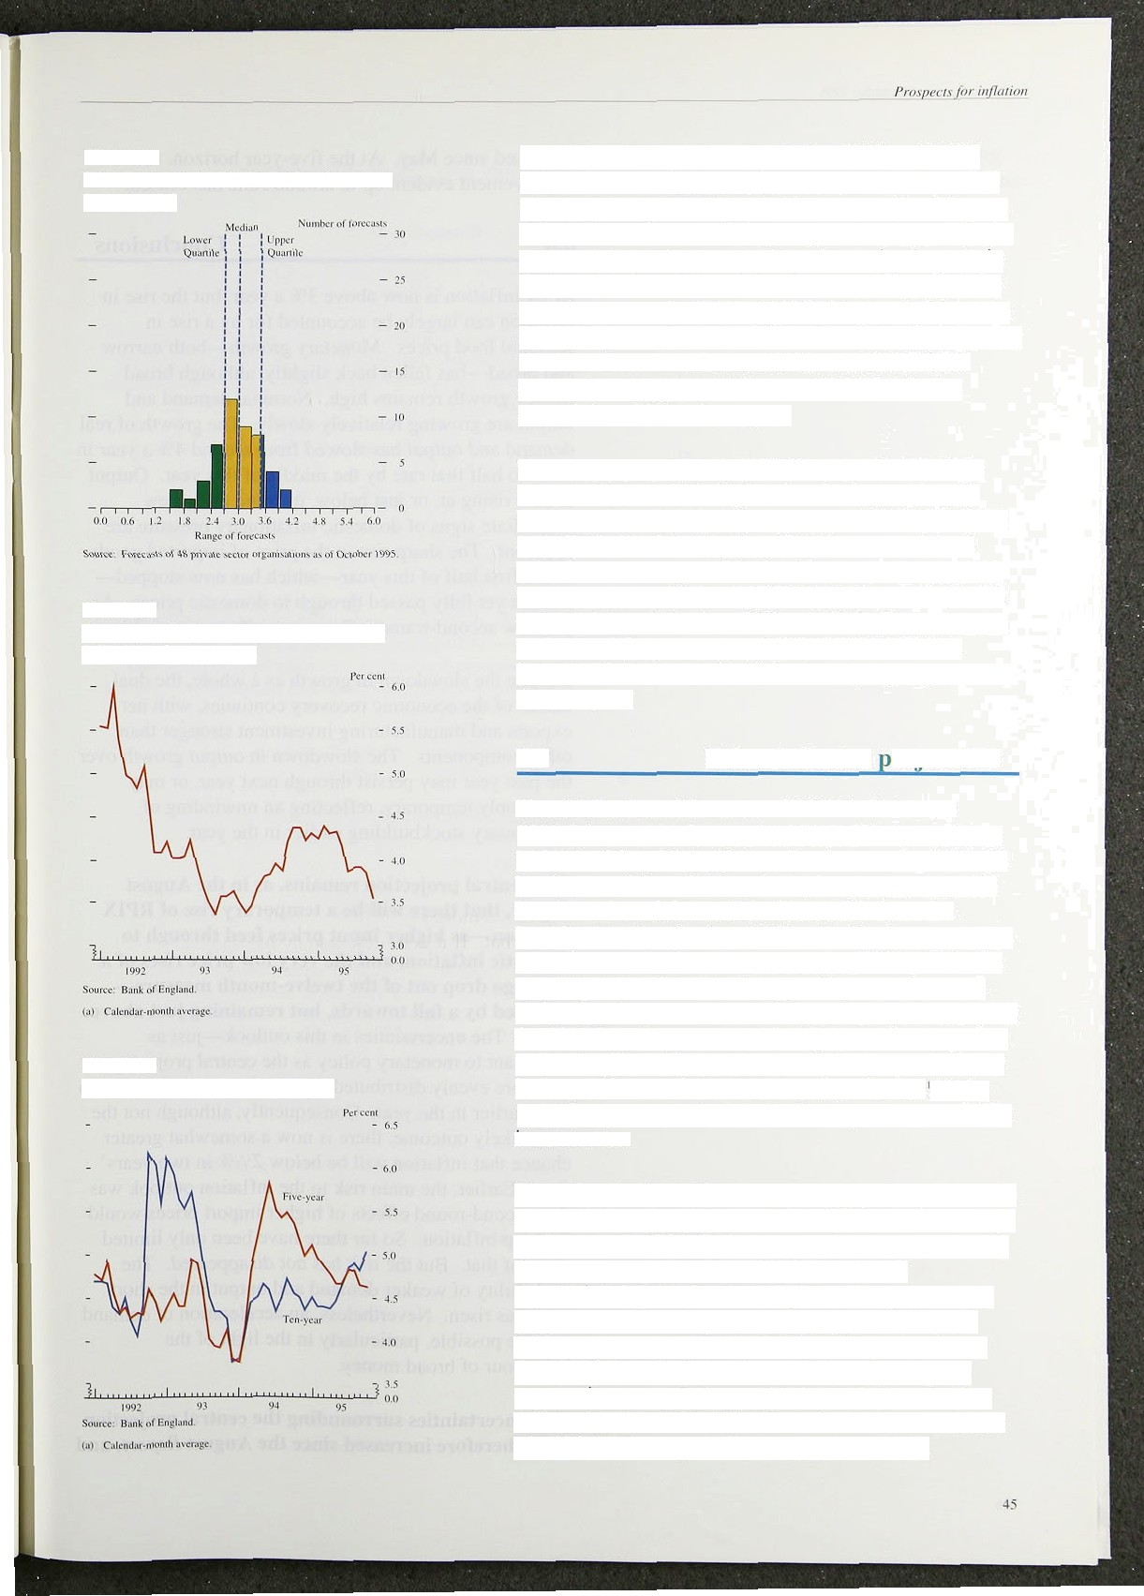**Chsrt 6.4**

**Dlstribution of RPIX jnf1ation forecasts**

for 1996 Q4

Chart 6.5

**Average inflation expectations over the**

**following three yeM•**

Chart6.6

**Implied forward inflation** ratest•i

The shape of the projected path for RPIX and RPIY inflation over the next two years is largely determined by the exchange rate depreciation seen earlier this year. This led to an increase in import prices and hence in the prices of domestic goods and services using imports in their production. Most of the first-round impact of the depreciation on the retail price level has probably come

through by now, but this still has the effect of pushing up the twelve-month inflation rate for some months to come—leading to a peak in annual RPIX inflation around the middle of next year.

The central projection for inflation over the next two years starts out a little higher than in August, largely because of the slightly higher-than-expected outtum for inflation in the third quarter. But the seasonal food price increases responsible for this should unwind over the next year, so RPIX and RPIY inflation are both still projected to peak in the middle of l99h. Thereafter, the new central projection has slightly lower inflation, because of a downward revision to output prospects over the next year.

* 1. **Other inflation roiecfions**

The distribution of forecasts of RPIX inflation for 1995 Q4 and 1996 Q4 collected by the Bank are shown

in Charts 6.3 and 6.4. The median forecast for 1995 Q4 has increased from 3.1% to 3.2%. but that for 1996 Q4 has fallen from 3.29c to 3%; this is still above the Bank's central projection. Unlike the Bank, many of the other forecasters assume changes in interest rates in the next two years, the majority expecting some increase.

Reflecting the greater uncertainty. the spread of forecasts for 1996 Q4, as measured by the interquartile range, has widened a little. Nevertheless, a higher pi‘oportion than in August forecast inflation to be at or below 2 /i9r by 199d Q4, and most of these also incorporate some fall in interest rates.

The reduction in medium-term inflation expectations can be seen in bond yields also. Chart 6.5 shows the average twelve-month RPI inflation expected over the following three years, as derived from a comparison of conventional and index-linked gilts and expressed as a calendar-month average. The average fell by around

half a percentage point around May this year and then dropped .further in September and October. Implied expectations over the longer term have behaved rather differently. Chart 6.6 shows how the twelve-month rate **of RPI** inflation expected in ten years’ time has



increased since May. At the five-year horizon, the improvement evident up to around June has ceased.

## Conclusions

RPIX inflation is now above 3% a year, but the rise in inflation can largely be accounted for by a rise in seasonal food prices. Monetary growth—both narrow and broad—has fallen back slightly, although broad money growth remains high. Nominal demand and output are growing relatively slowly. The growth of real demand and output has slowed from around 4% a year in 1994 to half that rate by the middle of this year. Output is now rising at, or just below, its trend rate. Few immediate signs of domestic inflationary pressure are apparent. The sharp rise in the price of imported goods in the first half of this year—which has now stopped— has not yet fully passed through to domestic prices. As yet, New second-round inflationary effects are visible.

Despite the slowdown in growth as a whole, the dual nature of the economic recovery continues, with net exports and manufacturing investment stronger than other components. The slowdown in output growth over the past year may per.sist through next *year,* or may prove only temporary, reflecting an unwinding of involuntary stockbuilding earlier in the year.

**The central projection remains, as in the August Report, that there will be a temporary rise of RPIX inflation—as higher input prices** feed **through to domestic inHation, and the very** low **price** rises of a year ago drop out of the twelve-month measu **followed by a fall towards, but remaining just above,** 2'/i%. The uncertainties in this outlook—just as important to monetary policy as the central projection— are more evenly distributed around the central projection than earlier in the year. Consequently, although not the most likely outcome. there is now a somewhat greater chance that inflation will be below 2'/i' o in two years’ time. Earlier, the main tisk to the inflation outlook was that second-round effects of higher import prices would push up inflation. So far there have been only limited signs of that. But the risk has not disappeared. The probability of weaker demand and output in the short term has risen. Nevertheless, an acceleration of demand is quite possible, particularly in the light of the behaviour of broad money.

**The uncertainties surrounding the** central projection have therefore **increased** since **the August *Report* and**

the range of possible outcomes is wider. Achieving the inflation target in two years’ time is by no mean.s assured. It will depend on how the present uncertainties are resolved over the coming months.

J7

#### Glossary and other information

Glossary ol’selected *terot8*





Except wherc otherwise s.tate.d:.l'the‹ source for 4.he dafa

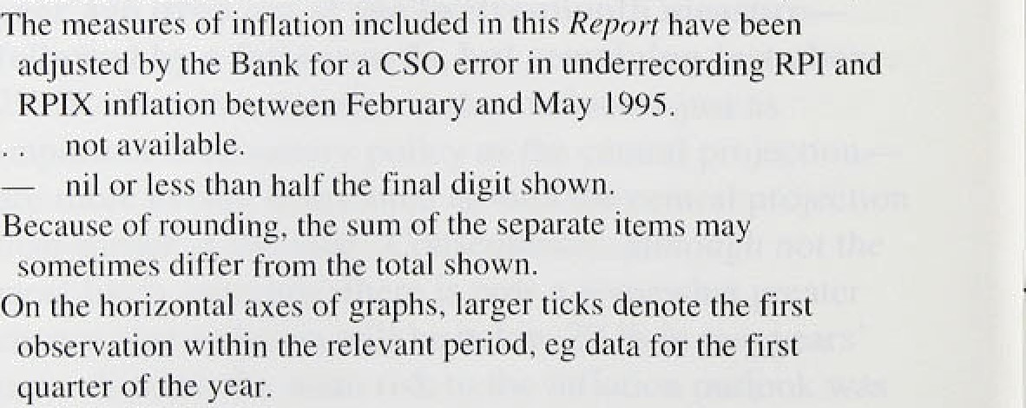







Price £4.00